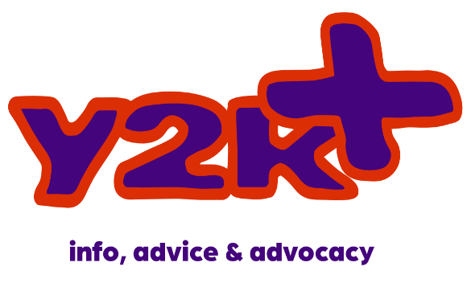
What is Y2K+?
Y2K+ is a one to one support service offer by Y2K for young people aged 12-18 years old.

What does Y2K+ offer?
Y2K+ can provide:
- Tailored 1-1 sessions for your support needs
- Group work surrounding various issues

Y2K+ can support you with difficulties in your life such as: anxiety, low moods, anger, school difficulties, family difficulties, bullying, lack of confidence, isolation and so much more.
Y2K+ offer a non-judgemental and safe space for you to be open and honest about the difficulties you are facing.

How does the referral process work?
Once your referral has been sent to us, it will be looked over by a Y2K+ worker. You will then be given an introduction appointment so we can tell you more about how we can support you!
Introductory appointment will take place

Any further questions do not hesitate to get in touch: ninagalloway@youth200project.com
Sessions will start as soon as possible
Referral received

