Peer2Peer Report
Y2K has delivered a wide range of tobacco awareness projects with young people accessing our services over the last three years. These projects have been supported through funding from LAYC tobacco grants. We have developed projects that have focused on the exploration of different aspects relating to tobacco use including the effects on health, e-cigs and vapes, cannabis awareness and the financial implications. Through all of these projects the issue of peer to peer supply became more prominent with many of our young people expressing that they were affected by this on a day to day basis. As a result, we developed a project that aimed to directly challenge this issue through fun, informative and creative approaches. LAYC funded our Peer2Peer project over a 12-week period that allowed us to deliver workshops and activities within our existing 180 service which works with young people involved in or at risk of becoming involved in risky, anti-social and offending behaviours. Many of the young people involved in this service were known to be those involved with the peer to peer supply of tobacco products and the majority were smokers. We also extended these workshops into our evening drop in services to reach a larger number of young people. After being approached by the NHS health promotion service to extend the scope of this project into high school, and as a result of additional funding from the NHS Lothian Health Promotion Service we were in a position to work with Newbattle high school pupils and staff to highlight and challenge this issue.
Between January and June 2019, Y2K has worked with 220 young people directly, within the Y2K project and Newbattle community high school. Peer to peer supply was of high relevance to the young people which allowed for some excellent discussion to take place and further awareness of the issue to be raised.
We encouraged young people to consider the reasons why peer to peer supply was a problem as well as exploring what they felt the positives were. From this it was clear to see that young people believed this was a legitimate way to make money as well as an easy way to access cigarettes when they wanted them. It was also identified that young people felt that by buying cigarettes from peers there were less likely to be implications for them.
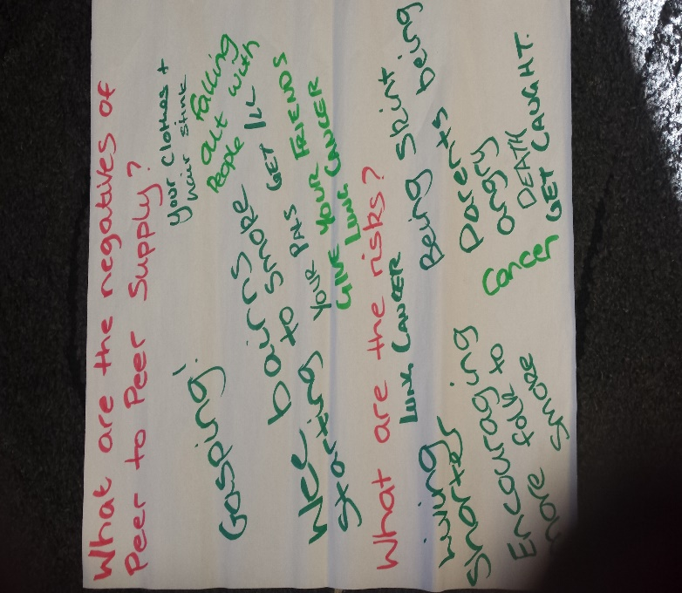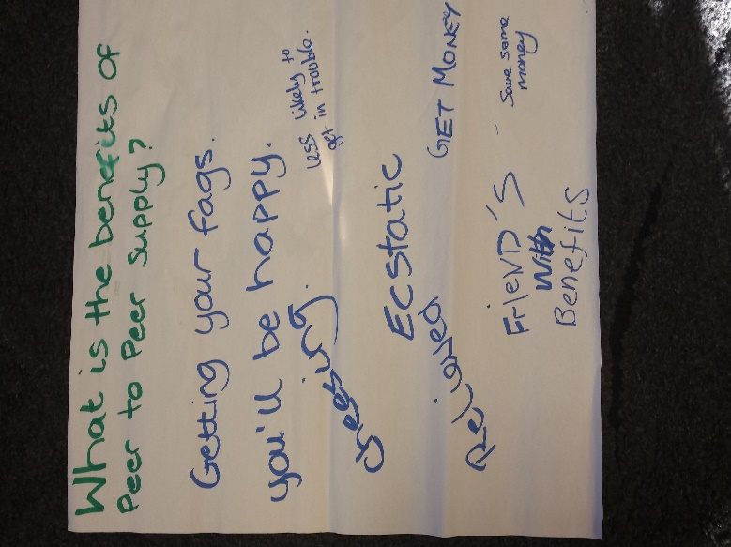

We spent a considerable amount of time discussing and exploring the moral implications of peer to peer supply. This seemed to have the biggest impact on the young people involved with many stating that they hadn’t considered this before. Issues such as young children being able to start smoking, encouraging vulnerable young people to buy tobacco products and young people using the limited money they may have to buy cigarettes. As a result of these discussions, four of the young people known to be involved in selling cigarettes to their peers shared that they felt less likely to sell cigarettes to others.
The other side of this debate however was that due to financial pressures on families in the community, selling cigarettes in some cases had become a way to bring extra income into the home. This highlights the difficult task it will be to challenge this issue when in fact there is a much bigger picture.
During the Easter holidays, we took a group of 16 young people who had been involved in the Peer2Peer project to Sky Skills Academy to produce and star in their own Sky News report. Those involved developed their own scripts and took on the roles of editors, directors, reporters and camera operators to produce their report which focused on highlighting the importance of healthy lifestyles, with a particular emphasis on the effects of smoking and peer to peer supply. All the young people thoroughly enjoyed this fantastic opportunity and developed invaluable skills through their participation in this activity.
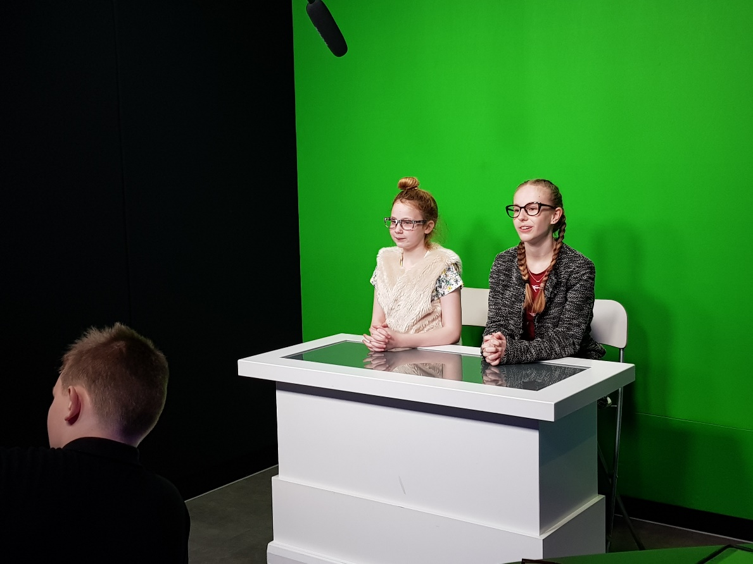

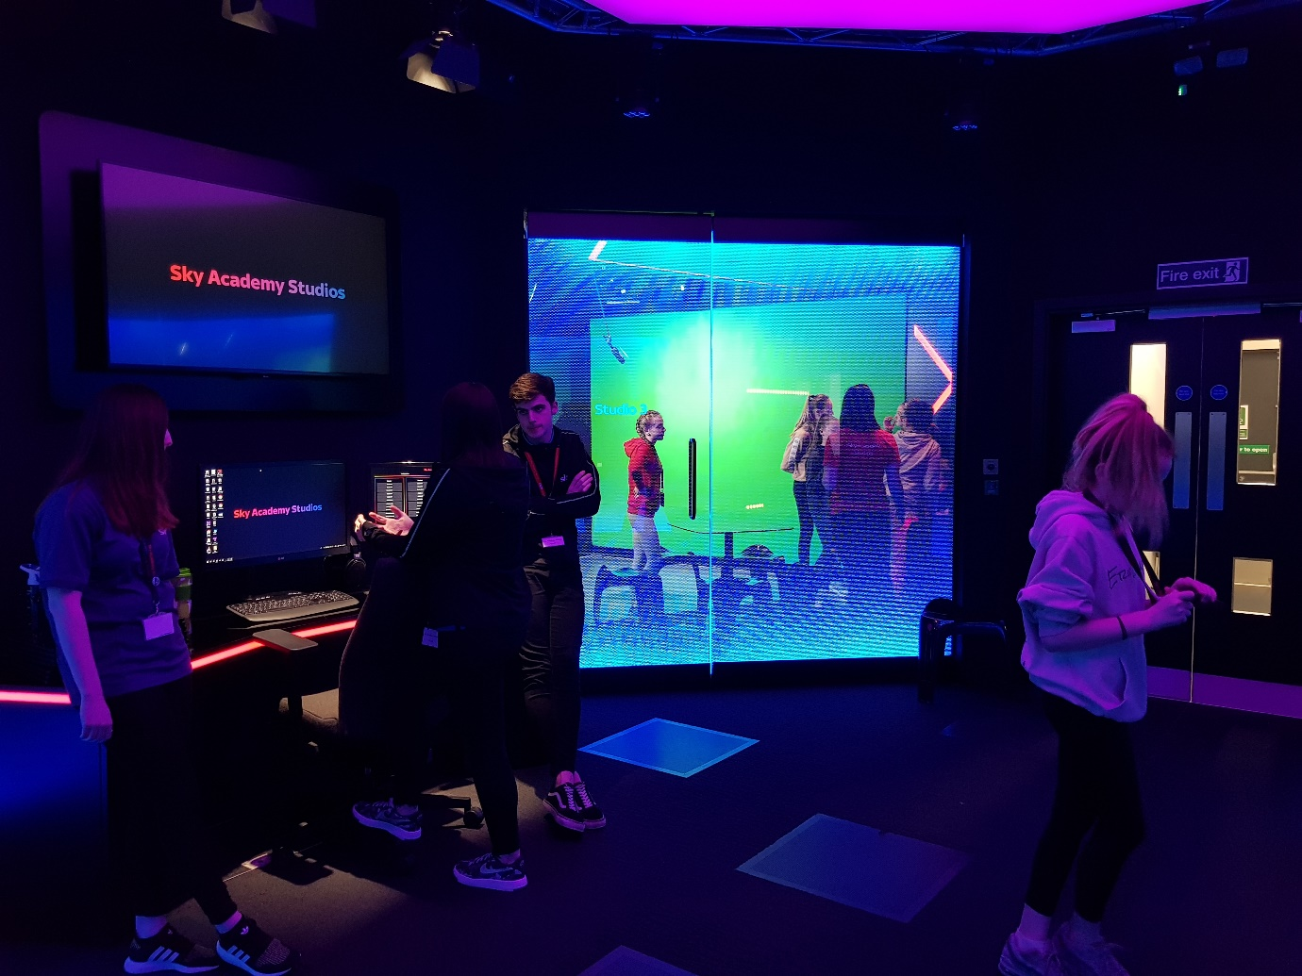

The youth worker responsible for the development and delivery of the peer2peer project met with the head of houses in Newbattle High School to make them aware of the work that had been going on around this issue within Y2K and to come up with an action plan that would allow us to extend the experiences and knowledge gained from this into the school.
The Sky News report produced by the young people was shared with the school for them to go on and use as an educational resource within PSE classes. It was also arranged that Y2K youth workers would be part of an S1 health fayre taking place within the school, delivering 15-minute micro tobacco awareness/peer to peer supply workshops with eight groups of over 20 young people. The workshop developed involved a mix of games and quizzes and ended with the young people watching the news report. This encouraged some excellent, insightful conversations to take place with the young people about the issue of peer to peer supply within the school. Each group spoke up clearly about the fact that there were lots of young people selling cigarettes in and around the school building.
“If I want a fag I know exactly who to go to get one and where they will be.”
“Its really nippy cause when you go out for lunch there’s always loads of people asking, do you want to buy a fag!.”
“Sometimes I see people in S1 just buying a fag event thought they don’t smoke cause they don’t want to get slagged off if they don’t want one.”

When asked if they thought more needed to be done to challenge this, the unanimous opinion was yes!
As well as working with young people in high school we also worked with a group of ten Primary seven pupils within Mayfield Primary. All of these young people had been identified as those who were at risk of becoming involved in risky behaviours. Workshops took place with the young people that involved using the tar jar and blood vessel resources to highlight the impact tobacco use has on our bodies. We also covered the topic of peer pressure and assertiveness, encouraging the young people to consider the ways in which they can say no to those who may encourage them to smoke without losing face.
As a result of the success of the Peer2Peer project and the learning that has taken place, Newbattle High School are now involving their pupils to work with them to consider the best way to challenge this issue. They have allocated funds to invest into future work with the young people and are keen for them to lead on any new initiatives.

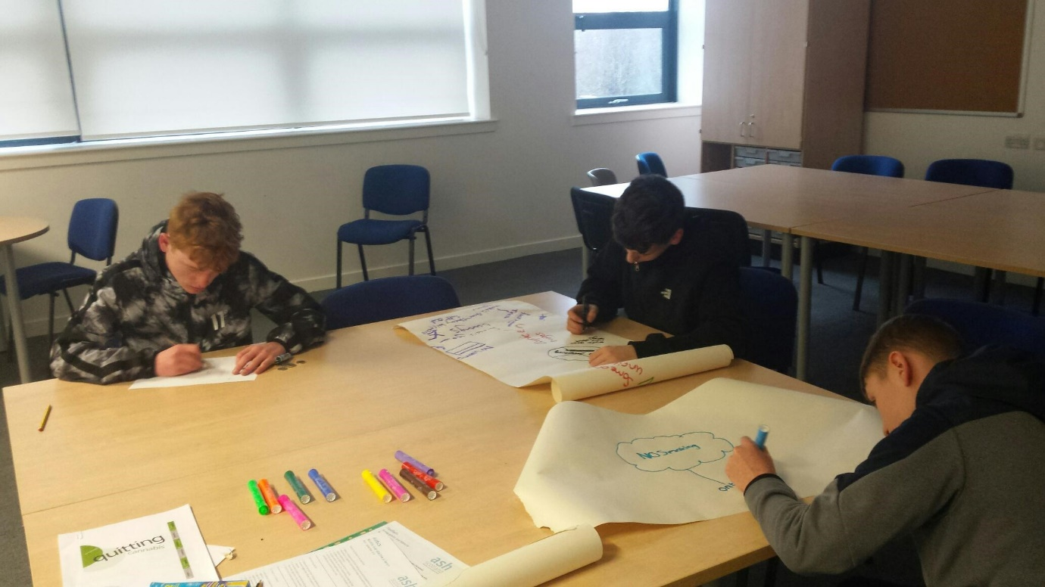

As part of the peer2peer project we surveyed 30 young people to gain an insight into their thoughts and opinions regarding tobacco use. 27 of those surveyed all expressed that in their experiences most young people accessed their cigarettes from peers, three of the young people felt that young people accessed their cigarettes by asking people to go into the shop for them.

Outcomes:
- 220 young people engaged with tobacco awareness workshops between the ages of 10 and 16.
- An educational resource was created by young people that will go on to be used within Y2Ks future projects and within school PSE classes.
- Newbattle high school are now exploring ways with their pupils to challenge the issue of peer to peer supply within their school.
- Information and experiences were shared with other professionals at the Tobacco Stake Holders event in Edinburgh.
- Partnership work with Fast Forward has been developed to raise awareness of the #notafavour campaign.

