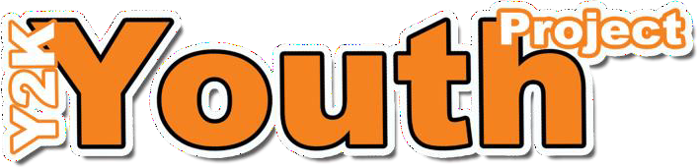

Mayfield & Easthouses Youth 2000 Project Membership Application
Y2K, 2b Bogwood Road, Mayfield, EH22 5DY
Tel: 0131 454 9805
Email: info@youth2000project.com :www.youth2000project.com

FAO parent/guardian/carer: This form MUST be completed by a parent/guardian /carer to ensure medical and emergency contact details are correct and to allow access to Y2K Drop Ins . Please note that all information provided in relation to membership to Y2K will be treated in confidence and with respect. Y2K requires this information in case of emergency and for statistical information.

Name of Young Person: | Age:
Address: | Date of Birth:
Postcode: | School Attended:  School Year: e.g. S1, S2 etc
Guidance Teacher: | Young Person’s contact number/email:

Emergency Contact 1

Name: | Home Telephone:
Relationship to you: | Mobile:
Email:

Emergency Contact 2

Name: | Home Telephone:
Relationship to you: | Mobile:
Email:
Medical Conditions:
Please inform us of any conditions, allergies or dietary requirements or any other important information you feel may be relevant.

Are you currently working with any other agencies? (social work, family support worker, activity agreement etc).....

Y2K exists to provide young people a safe space of their own, and as such Y2K seeks to create an environment that is open and non- judgemental for all young people. Any form of bullying behaviour or behaviour such as vandalism will not be tolerated in any form and should evidence of this be presented appropriate action will be taken.

Authorisation for Photography

Y2K occasional produces reports or publicity material about our work; we require the consent of parent/guardian for the use of such photographs. Young people will be full informed of how their picture will be used.
Please indicate if you do NOT wish to grant permission by making a mark in the box below or by speaking to any member of project staff.
No

Parent or Guardian signature (If young person is under 13 years of age)

Name (Print)……………………………………………………………………………………………...
Yes

Signature…………………………………………………………………………………………………….
(Parent / Guardian signature required only)

Yes
No
Young Person aged 13 – 16 years
(Young Person Parent / Guardian signature required)
Young Person (Print)……………………………………
Parent / Guardian (Print………………………………………………
Signature……………………………………………………………
Signature ………………………………………………………………………
Insurance Information
Young Person aged 17+
(Only young person required)
Name (Print)………………………………………………………

Signature……………………………………………………………

Y2K’s Liability Insurance will meet claims resulting from accidental injury or damage to property if it is proved it was caused by negligence of Y2K or a Y2K employee. Y2K insurance will not cover loss or damage to personal property.
Much of the statistical information required for funding applications is within this membership form and may be used for this purpose. This information may also be shared with other professionals and organisations. Please indicate if you do NOT wish to grant permission for this by speaking to any member of staff
Name of Young Person: | Signature of Young Person:
Name of Parent or Guardian: | Signature of Parent or Guardian:
Relationship to you: | Date:

