**MAYFIELD EXPLORERS**

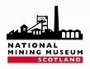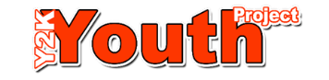

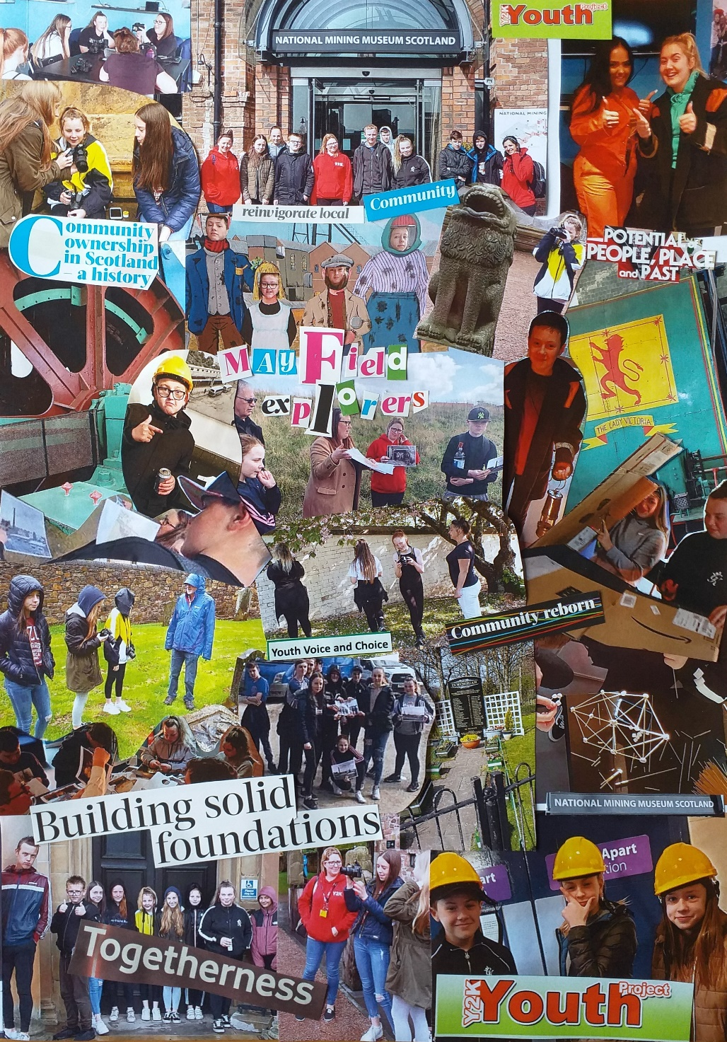

**EVALUATION**

**Content**

**1. Introduction**

**2. Aims of the project**

**2.1 The need for the project**

**2.2 Planned outcomes**

**3. What happened**

**3.1 Project management**

**3.2 Outcomes delivered**

**3.2.1 Outcomes for heritage**

**3.2.2 Outcomes for people and communities**

**4. Review**

**4.1 What difference did the project make**

**4.2 What worked well**

**4.3 What were the challenges**

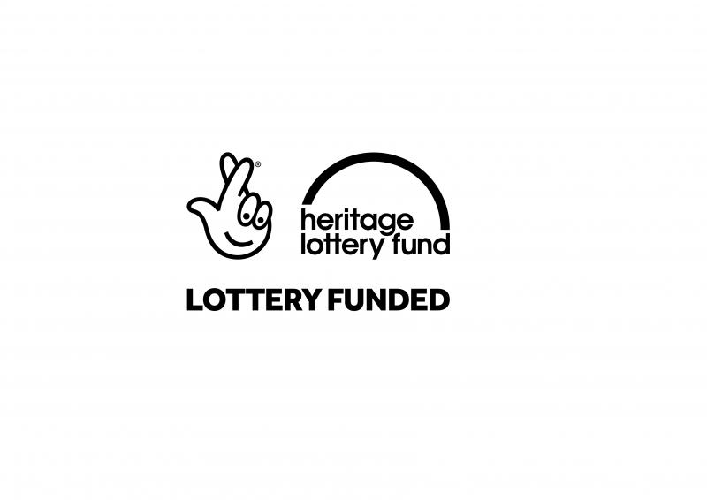

**1. Introduction**

The application to the Heritage Lottery Fund (HLF) was to ‘provide opportunities for young people to take the lead on heritage programmes to explore the extensive social history of their local community through free skills development workshops and activities creating learning opportunities with practical applications.’

To achieve this aim a partnership led by the Y2K Project Manager (PM) and the Education Manager (EM) at NMMS was created to deliver the Mayfield Explorers project.



**2. Aims of the project**

By the 1980s, most of Midlothian’s collieries had closed and were in the process of being demolished. This was followed by wide unemployment and urban decay in several of Midlothian’s towns including Mayfield and Easthouses. The National Mining Museum Scotland, known at the time as the Scottish Mining Museum, was established in 1984 to preserve and promote Scotland’s mining heritage and history for current and future generations. The aim is to do this through creatively inspiring discovery and exploration of Scotland’s mining past. Midlothian has a wealth of mining history and heritage which is slowly being lost with colliery sites being demolished/built over and memories of the mining industry being lost generation by generation. As the only community-based youth service in the authority, Y2K is in a unique position to educate and encourage community wide memory sharing. Many of the young people talk about feeling bored and having few opportunities in their own community and it has been the aim of the Mayfield Explorers project to encourage them to explore the rich heritage that surrounds them.

*“We have got very interested in where we live, the history and stories about our families and ancestors”.* **Mayfield explorer**

*“It is important to keep memories and pass them on. Once things are lost they are gone forever…”* **Mayfield explorer**

**2.1 The need for the project**

Mayfield & Easthouses are in the top 15% of most deprived communities in Scotland according to the SIMD 2020. School attainment levels are below the national average with 35% of local people aged 16+ having no qualifications. Youth offending, antisocial and risk-taking behaviours are rife and have an extremely negative impact across the wider community.

The communities are in danger of losing their mining heritage through the wealth of new housing developments and lack of any dedicated resources, heritage trails/information or even landmarks indicating that these towns developed from rural settlements to new towns due to the mining industry in Scotland.

Urban heritage has a considerable impact on the lives of people that live in, work in and visit our towns and cities. How people engage with and perceive their surroundings has an important influence on the overall quality of their lives. Surveys commissioned by English Heritage, CABE and the Scottish Government Architecture Policy Unit clearly demonstrate that, for most people, the built environment has a very significant influence on their well-being and quality of life. The Scottish Government’s National Performance Framework recognizes that encouraging creative activity, learning, and social interaction within urban areas

generates positive, diverse neighbourhoods with a real sense of community. Awareness of the histories and biographies of urban places can give them new meaning, bringing a heightened sense of ownership, value and community pride to residents - not least young people, promoting long-term care and wellbeing. Active engagement helps people identify personally with an area and feel more strongly that they belong, as well as potentially increasing physical activity and greater use of the outdoors.

Many of the young people who access Y2K services report feeling disconnected from their local communities. Perceptions of young people as 'trouble' are widespread and there exists a challenge to create opportunities for positive inter-generational connection.

*“We need different generations to appreciate and value each other… recognising the contributions that have been made in the past as well as what can be made in the future”* **Community volunteer**

**2.2 Planned outcomes**

**Outcomes for the component elements**

|  |  |
| --- | --- |
| **Participatory and historical research** | Action research through interviews, community mapping & photographic recording. Museum visits, internet research |
| **Oral history** | Intergenerational workshops and interviews |
| **Art/craft** | Photography, collage, mural painting, 3D model making |

**Associated outcomes**

|  |  |
| --- | --- |
| **Community events:** | Mayfield Gala Day  Y2K Big Birthday Community Bash  NMMS Family Fun Day  Heritage Hero Awards at NMMS |
| **Exhibitions:** | Mayfield Explorer exhibition at NMMS |
| **Training:** | 3 x 2day PAR training sessions |
| **Workshops:** | 3 Mine of information workshops – object handling  3 Reading maps workshops  3 Community mapping workshops  6 Photography workshops  6 oral history workshop/sessions |
| **Living Museum installation** | Final piece based on work from the creative workshops |

**3. What happened**

**3.1 Project management**

The Y2K PM had responsibility for overseeing the project as the lead partner along with the Education Manager (EM) at NMMS. The project was managed by the Y2K *Guid to Go* Project Lead (PL) a local resident, familiar with the mining heritage. The PL was responsible also for the direction of the Y2K Big Birthday celebrations in 2019 (funded by Awards for All) as part of the health, wellbeing and community connecting aspects of Y2K services.

In preparation for the application to HLF a steering group was formed of Y2K staff and youth reps. This steering group continued to meet over the life of the project. Each of the 3 programmes were monitored, reviewed and evaluated so that the learning could be shared, and each intake of explorers could be fully supported by peers and staff to have meaningful voice and choice in the content and flow of their experience. A youth-led perspective was maintained over the life of the project.

The EM and Assistant Curator (AC) from NMMS were the key staff involved from the museum providing their expertise/facilitation and access to the museum as 'in kind' support. As members of the steering group they played important roles in the project management.

The project also relied on the support and contributions of a range of community volunteers linked to Y2K as well ex-miner tour guides and NMMS volunteers. Y2K sessional youth workers were central to all the activities planned by the partnership and each of the partners took responsibility for managing their own staff and volunteers with the steering group being pivotal to the process.

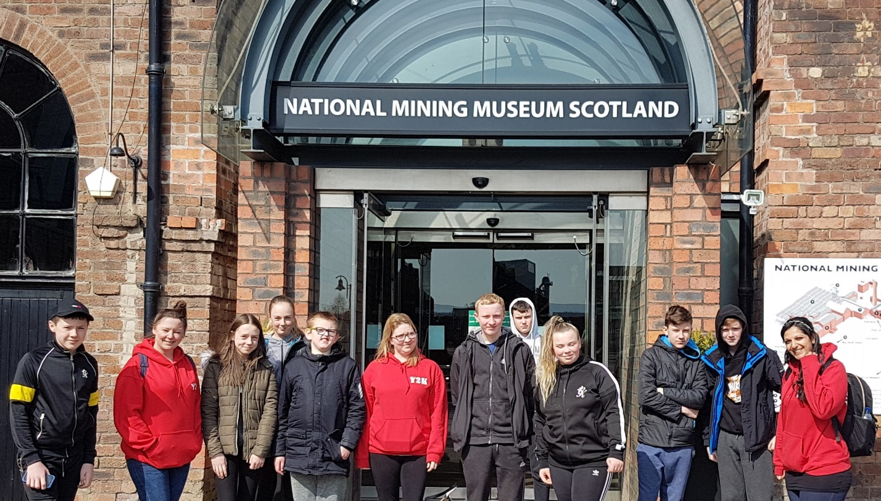

**3.2 Outcomes delivered**

*“One of the best things about the Mayfield Explorers project is that we learned that the place we live in is full of stories and history. Sometimes we think this is a bit boring and there is nothing much to do but when we were at Rosslyn Chapel you could see how many tourists and visitors come to find out about these places. It is the same with the Mining museum, you learn a bit about it in school, but you don’t always think that the place you live is as important or interesting as others do”.* **Mayfield Explorer**

The young Mayfield Explorers have learned about their heritage - they have increased knowledge and understanding through having access to opportunities to connect with their roots. They have enjoyed positive and fun experiences, shared their explorations and findings with peers and they have been supported and encouraged to communicate and further share this learning with others. Their explorations have uncovered what for them is less familiar or unknown about the place they have grown up in. This has led them on to further investigations and testing out.

They have been challenged to try new things and to open themselves up to changing their attitudes to their 'boring' community and the stuff of the past. They have been able to develop new skills and gain a sense of positive attainment though conserving their heritage and keeping it alive because they now believe that this is something worth doing. The young people have been able to make connections about the importance of legacy and how easily things can be lost if we do not take care.

**3.2.1. Outcomes for heritage**

**i) Strategic partnership**

The partnership between Y2K and the NMMS was already well established when the EM joined Y2K’s Board of Directors in 2017. Mayfield Explorers was a group set up by the young people in 2018 running on Wednesday afternoons as a pilot project linked to Y2K’s health and wellbeing service. Evaluation feedback led to the forming of a strategic partnership with the aim of developing a heritage programme to foster a sense of place and connectedness within a group of young people identified as ‘hard-to-reach’, ‘high tariff’ and NEET.

Commitment to this aim by both the NMMS and Y2K has created a unique opportunity to support the engagement of and produce positive outcomes for a diverse group of young teenagers.

*“We had access to the young people who aren’t engaging with school or any other service, but our challenge was to offer them alternative ways to try things out and develop confidence and enjoyment in their own skills and abilities. That sense of positive attainment and a broadening of horizons…”* **Y2K**

*“The Mining Museum was keen to reach out to more diverse groups of young people and as is the case for most museums in Scotland we struggle to engage with young people aged 15-26 – an important target audience.”* **NMMS**

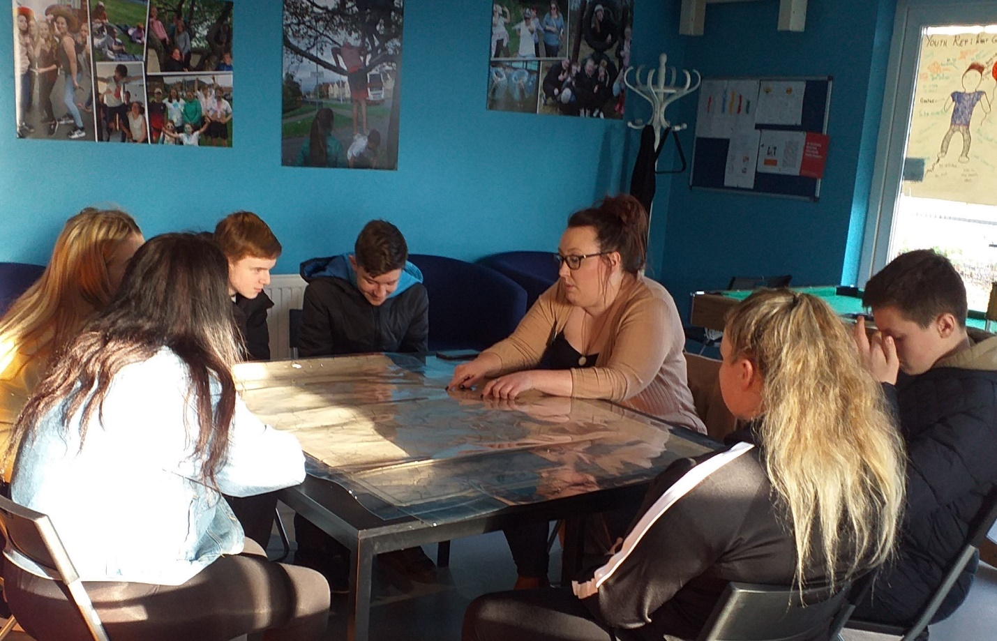

**ii) Mayfield/Easthouses heritage**

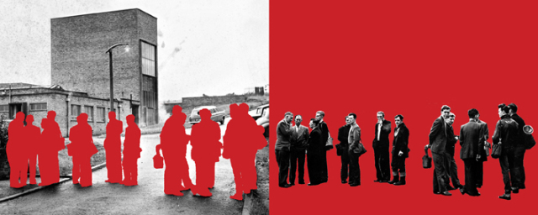

This project has worked to the benefit of the whole community and has involved residents, peer groups from school or training for employment as well as stakeholders promoting cross-generational connections. Paid workers and volunteers, church and community groups including other voluntary groups and agencies, local community councils and local businesses. Feedback from programme participants, the project team and community stakeholders indicates that pride in and connection to heritage has increased through participation.

Community stakeholders have given generously of their time, investing in effective methods of cross-generational communication. Meetings have taken place at Y2K and other community

venues and the young people organised and co-facilitated 'brew and blether' sessions.

Opportunities to benefit from stimulating, informal learning around heritage, storytelling, photography and model construction have built confidence, efficacy and self-esteem. The young people have gained transferable skills which will assist them into training and employability opportunities, bolstering their CV’s and building on their sense of positive achievement through ongoing participation in this project, enhanced by the awards they have achieved.

*“During each stage of the project the young people in the project were keen to tell myself and other NMMS staff what they remembered from the previous week, often with follow up questions, and to show us the new skills they had learned, such as with their new photography skills! As a heritage* organisation*, this project taught us the vital lesson that standard classroom learning doesn’t suit everyone and that broad workshops, with useful skills for the future, had a lasting impact on these young people and will encourage them to share what they have learned with others! Vital to keep the history and heritage of Scotland’s mining communities alive.”*  **Education Manager NMMS**

*“It’s great that the young ones show an interest and want to hear about what it was like [down the mines] – they really don’t have a clue nowadays but then why should they if they don’t get to hear about it”.* **Ex-miner**

**Component strands:**

**Research**

Community volunteers with a background in community learning and development offered training in Participatory Action Research (PAR) methods to the young participants. They introduced various tools including mapping, ranking, drawing, drama and video.

The project plan was designed and developed by the young people and some changes happened over the rolling programmes in response to the specific needs and interests of each cohort. Programmes included workshops, trips and learning opportunities which were recorded/reported on by the participants as evidence of their explorations/research.

*“It was good to get the tour round the old Easthouses Colliery site, Jim who used to be a miner and is now a tour guide at the Mining Museum was brilliant at telling us what life was like working in the mine. We looked at maps, but it was a bit confusing because things have really changed.”* **Mayfield Explorer**

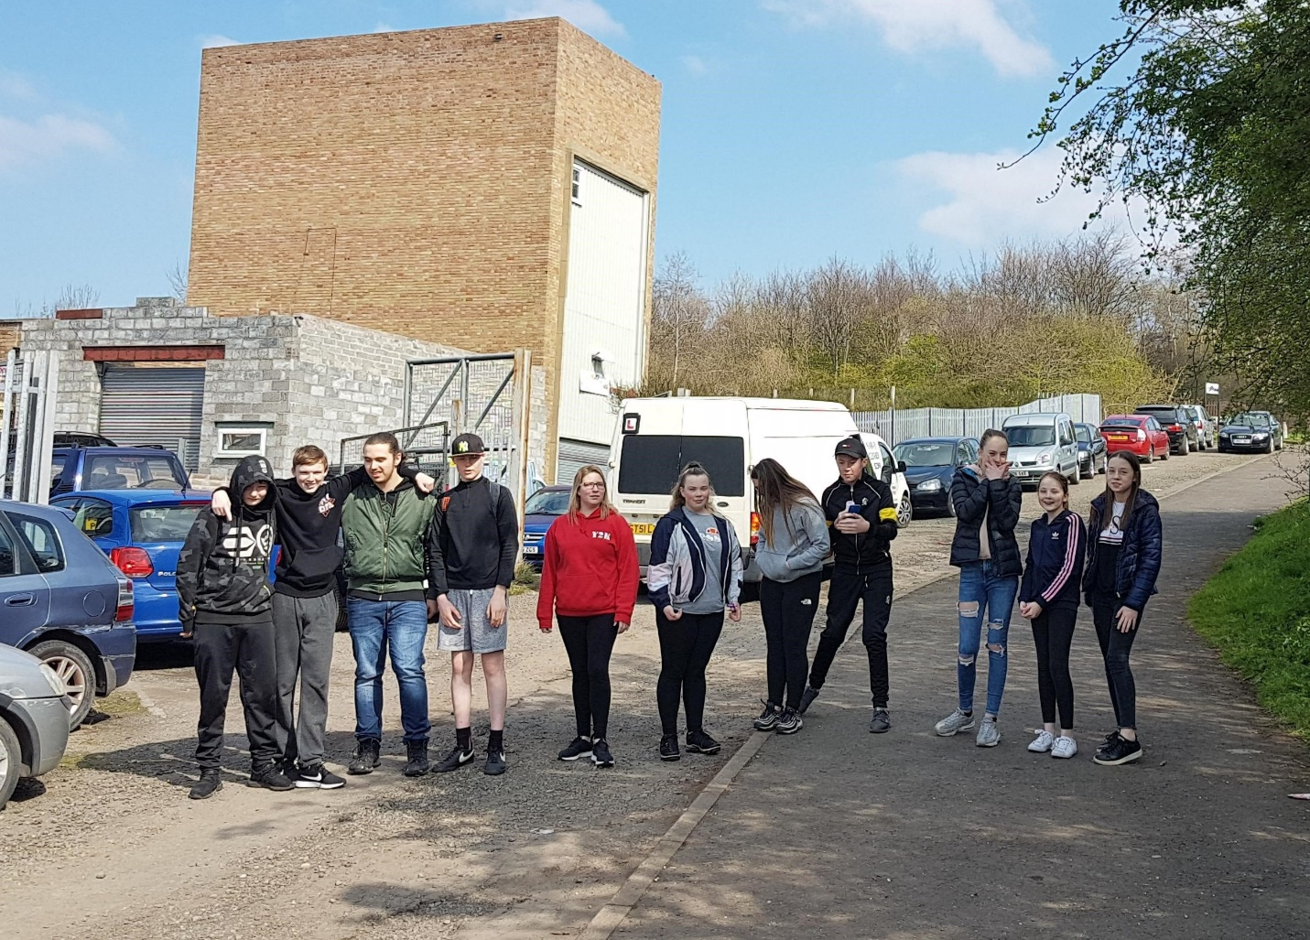

**Oral history**

Inter-generational workshops were organised by each programme intake with participants being invited to local miners’ welfare as well as reaching out to ex-miners to share their memories of growing up in Mayfield/Easthouses and their experiences of working at Easthouses or other local collieries. ‘Brew and blether’ sessions took place at Y2K and individual participants interviewed family members for the project.

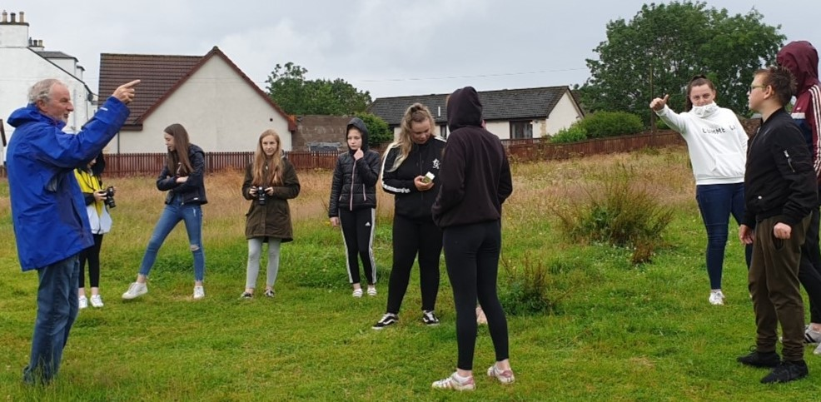

*“Our group was invited to join in with the ex-miners and their wives to pay respects to the miners who had died working in the Easthouses mine. We were able to talk to them and ask questions that we had prepared. They were very nice to us and answered our questions, telling us their stories which made us think about how much life has changed for young people leaving school now.”* **Mayfield Explorer**

*“Living here being down the mines was a family thing and you just had it in your blood. My dad told me don’t worry there’s a job for you as soon as you leave school so even when I was a young boy, I knew that I was sorted. As soon as I left school at 16, I went straight down the mine and it really made me grow up… you went in a boy and soon became a man!”* **Ex-miner**

**Art/craft**

A wide range of creative workshops were offered across not only Mayfield Explorer weekly programmes but also as inputs in *InvolveU* open-door evening drop-ins and during Easter, summer and October school breaks. This encouraged participation in the project from a more diverse group and age-range of young people.

*“I wasn’t in the Mayfield Explorer group, but I did a lot of the trips and crafts because they were interesting. Painting the wall murals was quality and we got to decide what was important”.* **Mayfield Explorer**

*“You can see lots of photos of me in the collages we made, and I think this shows that I enjoyed taking part.”* **Mayfield Explorer**

**Associated activity:**

**Events and activities**

The Mayfield Explorer project encouraged participation in youth volunteering and community connection through events and activities bringing local people together in cross-generational celebrations. In June 2019 Mayfield Gala Day marked its 30th anniversary with a parade and activities in the public park. The Mayfield Explorers opened doors at the project and had a stall and marquee in the park.

Also, in June the young people organised a Community Barbeque to celebrate the Y2K Big Birthday Bash with the unveiling of a garden wall mural designed and developed by them to mark the ‘coming of age’ 18th anniversary of the official opening of Y2K.

Inspired to build on the community links and intergenerational connections made through the process of Mayfield Explorers the young people began work to create a space in the Y2K building to welcome community members in. They took the decision to work with community partners to design and install an indoor mural – *“a living museum”.*

In February 2020 Mayfield Explorers held an awards celebration at the NMMS where programme participants received Bronze Heritage Hero Awards from Archaeology Scotland.

**Exhibitions**

Mayfield Explorers celebration exhibition was developed and installed by the young people in the mini miners’ room at the NMMS. It opened to visitors 8th Feb-1st May.

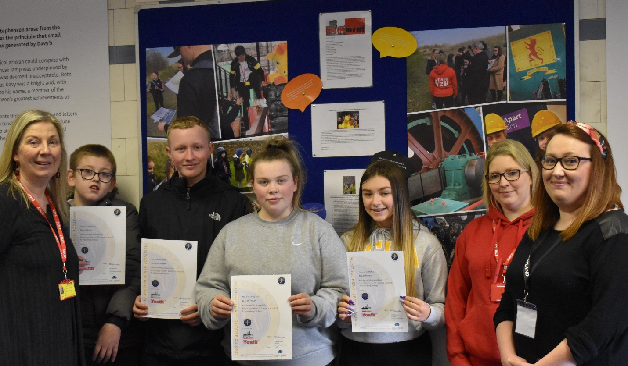

The Mayfield Explorers exhibition is in the main part of NMMS so will be accessed by nearly every person who enters the Museum. Based on 2019 visitor figures, between February and May over 5,000 visitors will have seen the exhibition.

**Living Museum installation**

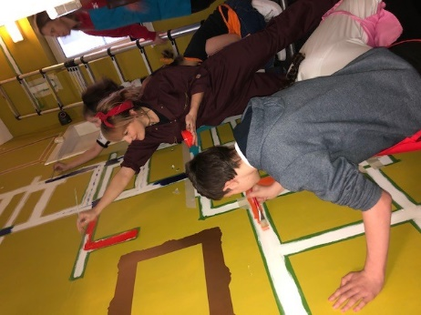 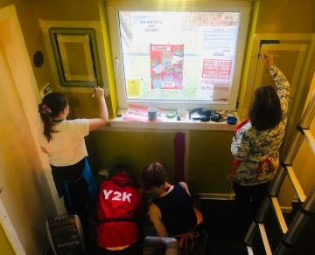 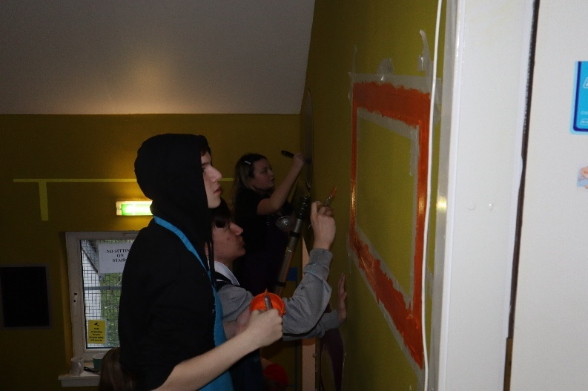

Work on the design and development of the living museum installation began in October 2019. The young explorers had taken the decision to create a living museum within the Y2K building by transforming the project stairwell with an indoor mural. The living museum will be unveiled at a community event in March.

The explorers intend that as well as having access to the mural via the Y2K and NMMS websites, local people will be able to visit the project and see the work for themselves through attending open-door coffee afternoons, fundraisers and events.

The installation comprises painting, photography, collage and re-positional prints which means that in the future displays can be ‘curated’, the ‘collection’ can grow, and objects/images can be ‘archived’ as the young people see fit.

*“When we were talking about making a digital museum that didn’t sound as interesting as making something with our own hands and seeing it every time we are in Y2K.”* **Mayfield Explorer**

*“It is brilliant that we can change things and add more stuff when we want to… makes it really ours.”* **Mayfield Explorer**

**3.2.2 Outcomes for people and communities**

Due to the focus and intention of the project the outcomes for people and communities

are closely inter-linked and cut across both the component strands and the associated activities.

Mayfield Explorers has brought together a diverse range of community stakeholders of all ages. Young people accessing Y2K services, staff and volunteers from both Y2K and NMMS as well as partners from Newbattle High School, Lifelong Learning and employability (LLE), Mayfield & Easthouses Development Trust (MAEDT), local community councils and miners’ welfare.

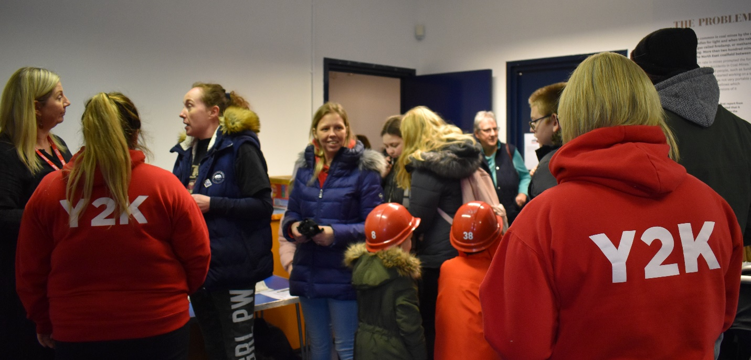

*“This has been such a positive experience for so many different people because it has involved folk joining in and delivering for different parts of the programme and activities over the year… talking and listening, willing to learn from each other.”* **Community Volunteer**

**Quantitative data**

**Volunteer hours**

Over 2,400 volunteer hours were donated over the course of the project.

**Activity data**

**Outcomes for the component elements**

**Planned Delivery Actual Delivery**

|  |  |  |
| --- | --- | --- |
| **Participatory and historical research** | 3 x 12week programmes  36 Mayfield Explorers  20 volunteers | 3 x 12week programmes  42 Mayfield Explorers  *86 individual young people participated in activities  30 volunteers |
| **Oral history** | 6 intergenerational oral history workshop sessions  Community volunteers/ex-miners and families | 6 group sessions (37)  3 ‘brew and blether’ sessions (15 individuals)  17 volunteers undertaking interviews, facilitating groups and producing summaries |
| **Art/craft** | 6-8 workshops (model making, collage, mural painting) | 3 x 3D model making (40)  3 x collage/cut and paste (28)  8 mural workshops plus ongoing design/installation inputs (46 individuals) |

**Associated outcomes**

**Planned Delivery Actual Delivery**

|  |  |  |
| --- | --- | --- |
| **Events:** | Community participation  Heritage Hero Presentations | Mayfield Gala Day (35)  Y2K Big Birthday Bash (52)  NMMS Family Fun Day (23)  24 Awards presented |
| **Exhibitions:** | Mayfield Explorer Celebration Exhibition | Exhibition running 08 Feb – 01 May 2020 |
| **Training:** | 3 x2day PAR trainings | 3 trainings delivered (42)  25 Heritage hero awards  14 Dynamic youth awards  10 Saltire awards (volunteering) |
| **Workshops:** | 3 Mine of information  3 Reading maps  3 Community mapping  6 Photography  6 Oral history | 3 Mine of information (36)  3 Reading maps (32)  3 Community mapping (42)  6 Photography (42)  6 Oral history (42) |
| **Living Museum installation** | Final piece based on work from creative workshops etc. | In process, due for completion March 2020 |

**Staff and volunteers**

*“I have lived here all my life but leading this project I learnt so much about the history and visited places that I had only driven past without thinking about the significance. Think it was good for the young people to see all of us [project team] get into the stories too!”* **Project Lead**

The project team comprised the EM (NMMS), PM (Y2K), PL (Y2K), two sessional youth workers, 10 community volunteers and four youth volunteers. A further 20 volunteers provided support to the project on a regular basis offering training, group facilitation and practical inputs (minibus and walking tours etc.) across the three programmes.

*“It has been eye-opening seeing the young people engage with the collection and especially our photography collection. As a legacy we hope to actively encourage more young people to creatively use this collection to use, enjoy and share their perspectives in new and unique ways. This project has shown again and again that young people have fresh approaches to accessing and sharing history and we must cultivate this passion for current and future generations.”* **Curator NMMS**

**Participants**

36 individual young people aged 12- 18 and 6 young adults aged 19-25 formed Mayfield Explorers. A further 44 young people accessing Y2K *InvolveU* drop-in and *Helfy Guid* health and wellbeing services also participated in Mayfield Explorer trips, workshops and activities and provided feedback on their experience.

“Vicki brought lots of things to Y2K so we could get a close-up look and handle the amazing things.  It wasn’t like being at school, we felt like we were in charge and had responsibility to take care of this important stuff.” **Mayfield explorer**

**Community**

As the only community-based youth service in Midlothian Y2K plays an important role in offering a range of services and supports within one of the most deprived areas in Scotland. The Mayfield Explorers project has played an important role in promoting specific intergenerational work bringing together a diverse range of community stakeholders and young people through a stimulating programme of trips, activities and learning opportunities.

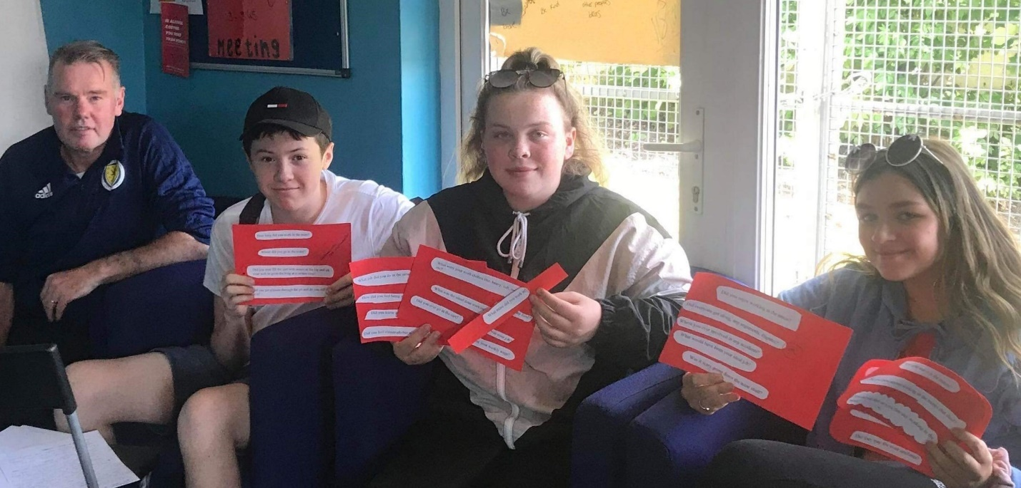

**4. Review**

**4.1 What difference did the project make**

It is widely acknowledged by the project’s partners and those involved in all aspects of the project that the richness of Mayfield/Easthouses’ mining heritage was at risk of being lost to the current generation.

The project has had an impact not only on the young explorers who completed the programme but also on the project team, community partners and other young people who were on the fringes of the project but who joined in with tours, trips and creative workshops. The level of community engagement varied across different activities, but the inputs from ex-miners and their families brought the project to life.

In a small but powerful way Mayfield Explorers has scratched the surface and the project team and young people hope that the living museum will keep up the momentum.

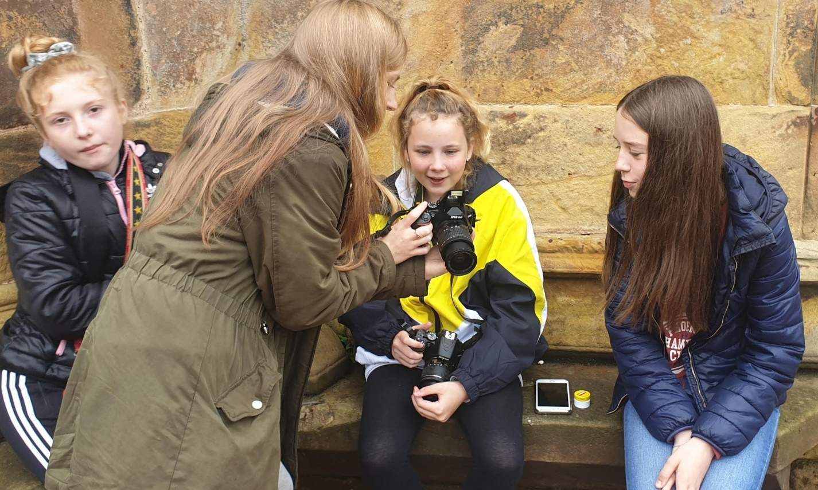

**4.2 What worked well**

**Project management**

The project achieved what it set out to do in delivering programmes of activities that explored the social history and mining heritage of their local communities. Outcomes were achieved through the workshops, activities and events across the three strands of the project. All elements of the Mayfield Explorers project were delivered and, in most cases, exceeded.

**Partnership**

The partnership between Y2K and the NMMS was a success and there were no real challenges since the partnership agreement very clearly set out expectations, roles and responsibilities. Staff sickness during the first programme meant that some re-scheduling had to happen, but this was sorted out very quickly and without any adverse impacts on delivery or outcomes. This was helped by the open communication and flexibility of approach of both partners.

**The strands working together**

The different strands of the project were interlinked from the outset with the programmes designed by the steering group from a distinctly youth-led perspective.

The aim was to reach out to a diverse group of young people to encourage participation of those who might otherwise be put off by the idea of a ‘history’ project.

***The strands complemented each other and worked to ensure that the project stayed true to its ‘one size does not fit all’ approach to youth engagement.***

**Art/craft component**

The arts and crafts component was embraced by the explorers and along with the trips and tours it paid dividends in encouraging broad participation in a range of activities by otherwise non-engaging young people. This project has shown how art and heritage work together to provide a narrative giving expression and voice to the young people to communicate their experience and understanding of what they are uncovering.

*“The photography and the mural stuff was the best… I liked mucking about with the cameras and taking the close-ups. I think I was one of the best at that”* **Mayfield explorer**

*“When the young people are doing the arts and crafts activities it can be a really useful way to break down any awkwardness they may feel engaging with us or their peers in a relaxed and open way… less ‘performing’ more enjoying!”* **Project team member**

**4.3 What were the challenges**

**Team support**

Training was provided to all staff and volunteers taking part but because there were so many community volunteers offering various inputs and activities across the three programmes it was sometimes difficult to arrange supervision.

**Social media**

The young explorers faced some challenges in producing digital content for use in social media due to problems with Wi-Fi access at Y2K and ongoing issues with the internet provider over the first four months of the project. Because of this, momentum and interest in digital media were negatively impacted although good progress was later made (by programme two) when a new internet provider had taken over.

By this time the arts and crafts component had been embraced by the project team and the decision had been taken by the explorers to plan for a ‘living museum’ as an end of project piece.

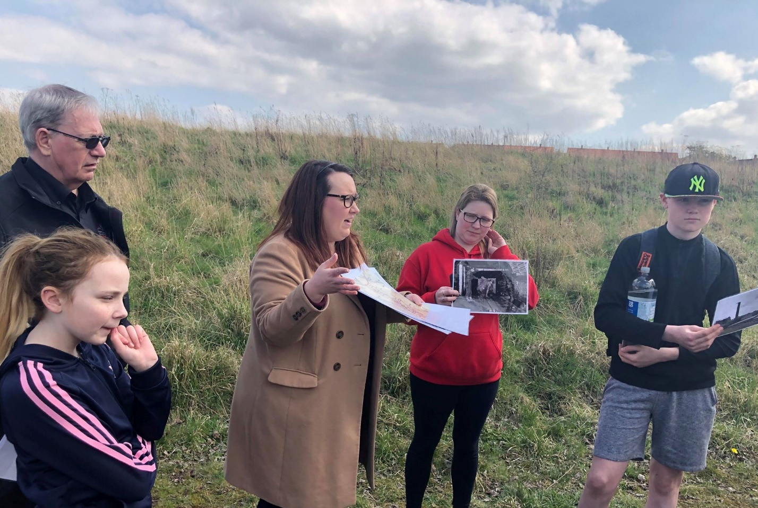

**5. Evaluation feedback**

All aspects of the Mayfield Explorers project were recorded and reviewed using creative methods to capture feedback and experiences in a way that will translate to peers and to members of the wider community:

* Numbers attending each session
* Feedback from young people
* Feedback from volunteers
* Feedback from stakeholders
* Individual self-assessments with targets
* Mountain (group) assessment to establish baseline
* Combination of group and individual assessment (peer support and feedback)
* Increase in skills and new experiences/confidence (Shanarri Wheels)
* Progress in health and sense of wellbeing, decision making and self-efficacy
* Use of digital media – has been limited (problems with wi-fi/internet provider)
* Photos, video clips (Facebook)
* Community events (exhibitions, award ceremonies and ‘gatherings’)
* End of project celebrations (Exhibition at NMMS, Living Museum at Y2K)

Self-evaluation feedback from the 42 young Mayfield Explorers who completed the programmes evidences:

* 95% say they feel more confident asking questions, speaking up and making choices.
* 90% say they have had fun and built positive relationships through their participation.
* 82% tell us they have learned new skills
* 75% have achieved one or more youth awards through their participation.
* 65% say they feel more connected to their local community.

The young explorers continue to be supported to apply learning from their challenges and experiences. Opportunities to train and become involved in peer coaching and mentoring has led to an increase in numbers of Youth Reps and Youth Champions at Y2K.

*“Since I have been doing volunteering with Mayfield Explorers I have got to know more people from the museum and from other groups in Mayfield. They all want me to get involved with them which is a good feeling.”* **Mayfield Explorer**

