Gambling Awareness Project
Don’t Be a Loser
Over the last six months, Y2K has delivered our gambling awareness project with 34 young people between the ages of 11 and 17. Our youth reps were keen to apply for a grant from Fast Forward as they identified that exposure to gambling was a real issue in the community and they were interested in finding out more about the issue, through fun creative activities.
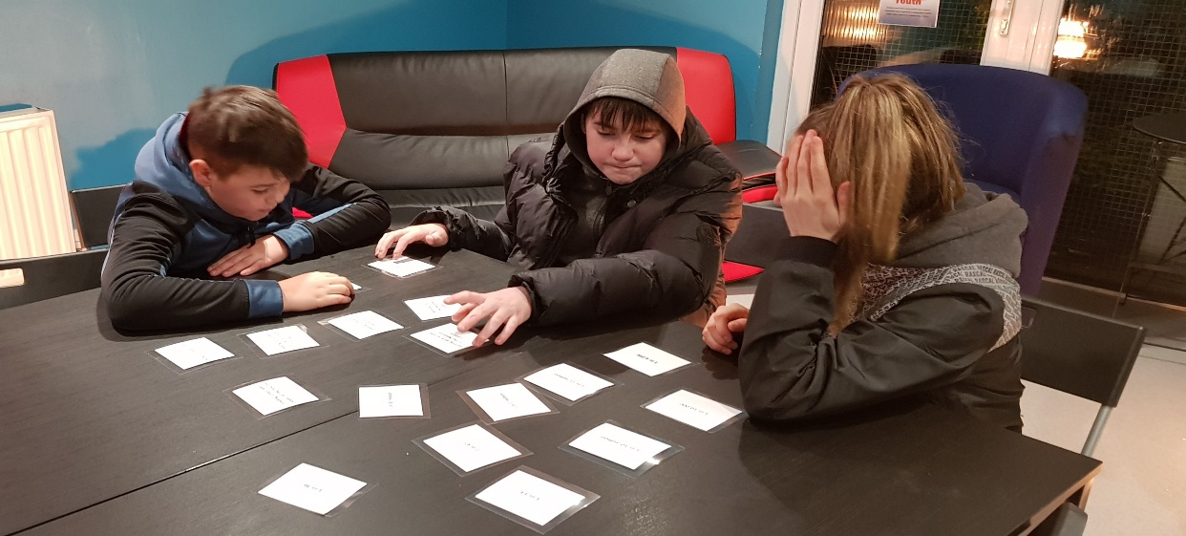
In order to get young people thinking about the issue and to highlight how prevalent gambling is in our day to day lives, we delivered a range of informal workshops within our Involve U drop in sessions and our 180 early intervention and prevention programmes. This allowed for some excellent discussions and learning to take place.

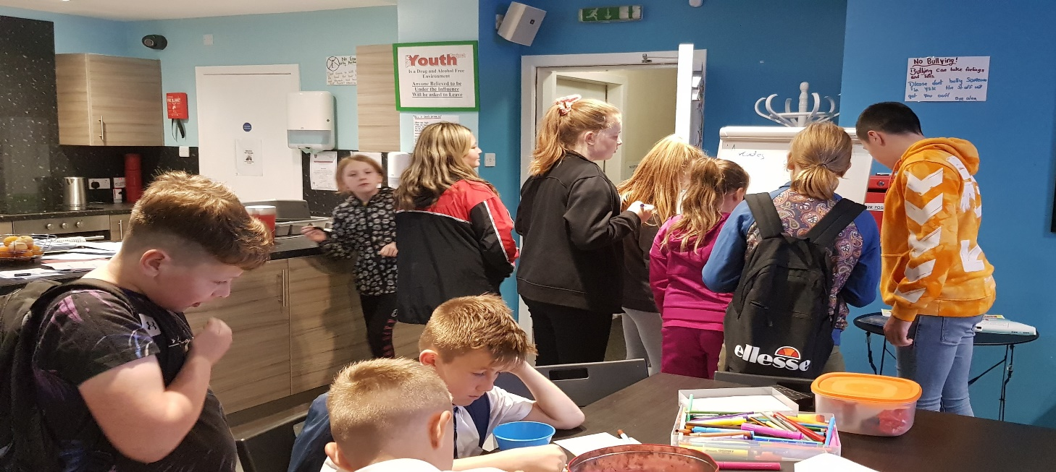

As a result of the insight gained through participation in our workshops, the young people decided they would like to create their own educational resource that could be used to raise awareness of the issue with a wider audience. In October we attended Sky Skills Academy where the young people directed, starred in and edited their own gambling awareness Sky News Report. This was a fantastic day for all who participated, with lots of opportunities for young people to develop new skills.
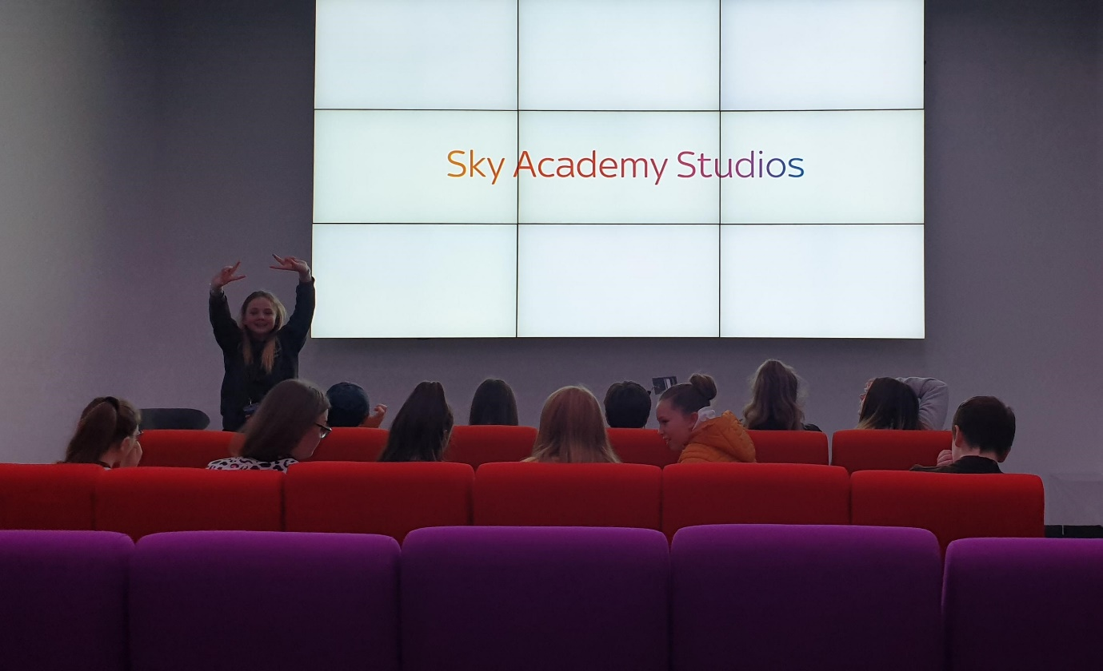

The next stage of the project was to hold our own “Be a Winner” community quiz night. This was an informal, fun evening with a non-judgemental approach to highlight how gambling is so prevalent in our day to day lives. It was great to see parents, community members and young people get involved. We also used the event to showcase the Sky News Report and to highlight the key messages that the project set out to achieve.

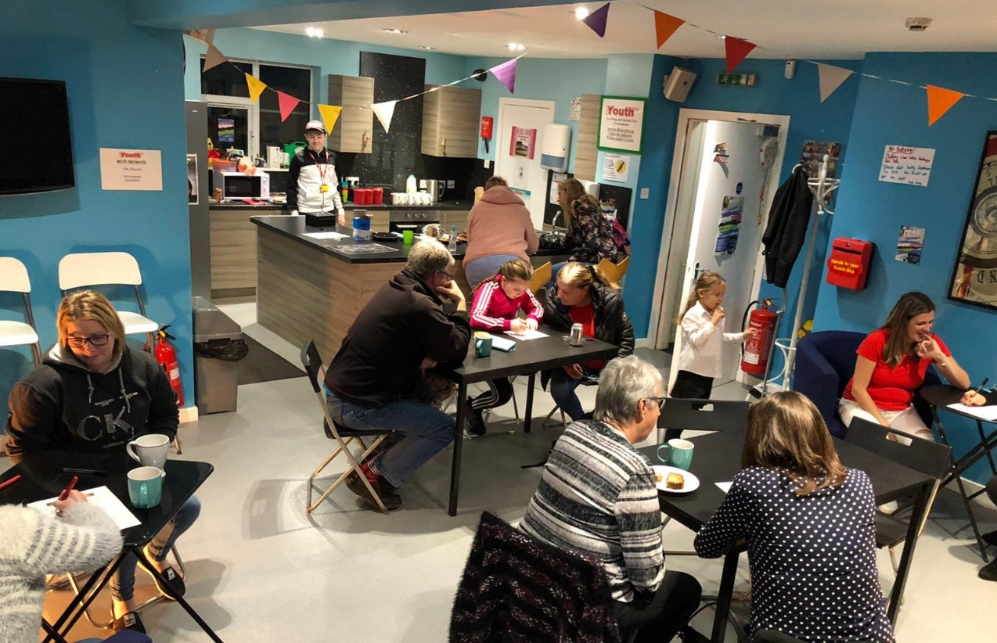

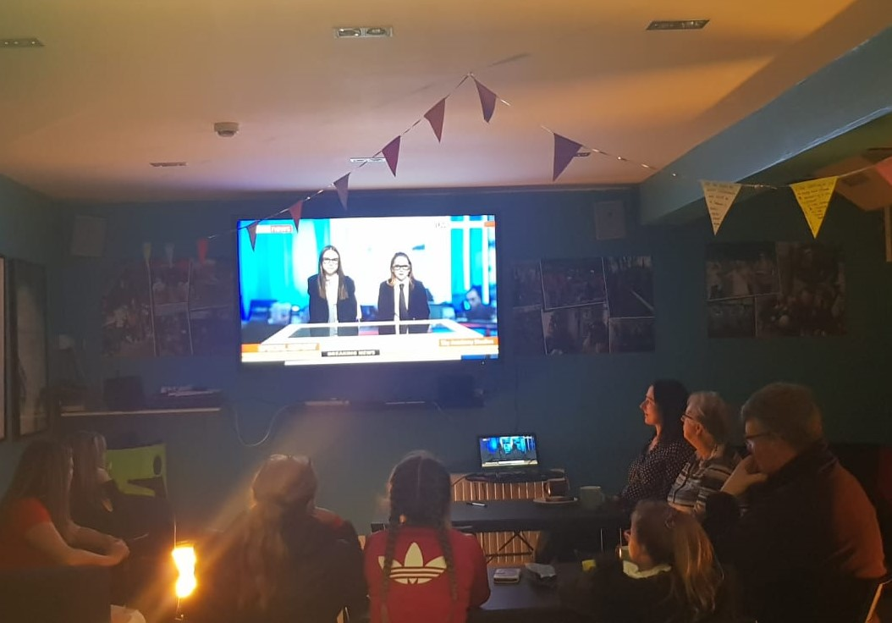
The youth work team attended a Fast Forward training session around gambling awareness in January 2020.

Going forward we will include gambling awareness sessions within our various programmes, using our sky news report to share information and highlight the dangers. We will continue to use the tools gained from the training to work with young people and encourage open discussions around gambling.

