When talking to a Y2K member of staff you have a right to expect anything you say will not be spoken about or passed on to anyone outside the Y2K Staff Team without your permission

Unless….

The Y2K staff member feels that something you have said means you are in a dangerous situation or could be hurt in some way and they are concerned about your safety.

In this case….

The staff member will first ask your permission to tell someone else. If after this, you still do not want the worker to tell anyone else but the Y2K Staff team believe you need to be protected, the staff member may then decide they have a responsibility to go against your wishes and talk to someone else ( e.g. teacher, doctor or social worker) outside Y2K

You will always be told first if this is going to happen. At all times Y2K Staff will act in your best interest.

If you do not understand any of this please ask a Y2K staff member to explain this to you.

Anything that a young person chooses to share with a member of staff or volunteer must be treated with the utmost respect

Staff and volunteers are not allowed to „keep secrets‟ and anything shared with a staff member of a serious nature (including something which puts themselves /others at risk) has to be shared with other staff members.

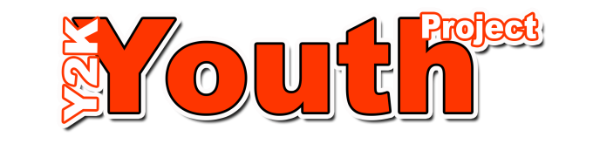
If young person requests information that Y2K holds about them this should be arranged with the consent of Project Manager to ensure it is done correctly

