180 Service at Y2K
Early Support & Prevention Approach to Youth Offending/Anti-social Behaviour

Context
Mayfield and Easthouses Youth 2000 Project (Y2K) serves an area that is typical of Scotland’s coalfield communities. Easthouses is one of the oldest mining villages in Scotland, built in the early 1900s while Mayfield was constructed very close by in the 1950s to meet an increasing demand for houses for mine workers from the Easthouses and Newtongrange collieries. The community of almost 8,000 people suffers significant deprivation – according to the Scottish Index of Multiple Deprivation (SIMD), around half the area is in Scotland’s most deprived (15%) communities, deprived in terms of income, employment, health, education, housing, access and crime.

Midlothian Council data shows that Mayfield/Easthouses has a higher proportion of young people in the population than Midlothian or Scotland, and a lower proportion of people over the age of 65. The long-term impact of deprivation on young people is well documented, and this project is focused on addressing the particular needs of young people in this community.

Project Background
Based in Mayfield and Easthouses, Y2K has a clear and strategic mission and vision.

Mission: “To support and encourage young people in Mayfield & Easthouses to be healthy and happy individuals through our delivery of holistic youth-led services.”
Vision: “Our vision is for young people in Mayfield & Easthouses to be healthy and happy, feeling safe and secure to become confident, fulfilled individuals.

Y2K is the only community-based youth service in Midlothian, and the only youth service of any sort that keeps its doors open in the evenings. This is particularly important in an area that is geographically isolated, prone to high rates of petty crime and other deprivation impacts. It is a gateway to other sorts of services, signposting and referring young people to specialist support, mainly through its Children in Need funded support service, Y2K+. Historically, like many third sector youth service providers, Y2K has been funded to provide support to young people by the local authority. And like most council funded third sector services, Y2K now finds itself having to address deep cuts to funding, reflected across Scotland in an increasingly difficult funding environment for local government.
Y2K was set up in 2000 by local businesses that recognised young people in the area had no place to ‘hang out’ or call their own. Today, the expressed need for high quality community-based youth work is as important as ever with more than 500 individual young people accessing the project in 2018. Records over the last 12 months show that the young people who have accessed Y2K services have faced disadvantage in a number of areas.
These include poverty; caring responsibilities for both siblings & parents; bullying; child protection issues including neglect and abuse; learning difficulties; living within families where there is domestic abuse and having parents with addictions. The young people all too often have a poverty of aspiration in terms of what they believe they can achieve or what they are worth.
This further impacts their marginalisation when it manifests in violence and abuse, young people experiencing physical and mental health problems, truanting, low educational achievement, feeling isolated and becoming involved in risky/self-harming behaviours.

Through a joined-up approach involving community stakeholders, as appropriate, and engagement with a range of services tailored to the various needs of our young people, Y2K aims to address these challenges, promote alternatives & build community resilience.

InvolveU open-door ‘drop-ins’ run two evenings per week when all other services are closed and operate as a popular and effective gateway service with 25-45 individual young people accessing the project each session. The drop-ins work to connect and sustain typically ‘hard to reach’ young people within the wider services (or signpost on as appropriate.) There are no costs associated with accessing drop-in activities and Y2K has an open door policy to ensure the service is as accessible and inclusive as possible. InvolveU aims to reduce the risks of some of the most vulnerable and disadvantaged young people in Midlothian, protecting them from harm and providing them with support, nurture and a range of informal education opportunities.

Y2K has built up a portfolio of services taking a lead from the young people themselves and also working with a range of community stakeholders to ensure that all projects, programmes and activities are in line with organisational vision and values and involve early support and prevention methods.

Background to 180
In summer 2016 Y2K received funding from Foundation Scotland Express Grants to run a 6week programme of diversionary workshops and activities aimed at young people involved in anti-social and risk-taking behaviours. This programme proved to be very successful in engaging young people considered, at that time, to be among the most “high tariff” in the area. Y2K staff worked with community police officers and the local fire safety team to devise short-term initiatives to reduce offending and harmful/risky behaviours. Following on from the end of the grant period Y2K continued to work with community justice partners to facilitate and deliver pop-up workshop inputs and themed sessions around drugs and alcohol awareness, personal safety, violence and abuse, rights and responsibilities and healthy choices/healthy relationships. All topics covered and specialist inputs arranged come from suggestions made by the young people identifying themes relevant to their day to day lives.

In summer 2017 Y2K staff carried out a survey of young people (11-18) accessing InvolveU drop-ins. Among 50 completed responses all had some experience of criminal behaviour. Causes cited were unemployment, having no money, nothing to do and peer pressure.

“I haven’t been involved with crime yet, but I think I probably one day will, cos all my mates do it and if I don’t, I will be called a geek or wimp.” (12yrs)
“It’s hard to move on with your life after doing something wrong. I am now labelled as a criminal even though it was a one-off mistake. Now I am targeted and can’t go out without worrying. I even lost my job.” (17yrs)

In November 2017 Mayfield Community Council called a public meeting in response to an unprecedented spike in youth offending and anti-social behaviour across the local community. There were numerous reports of vandalism, burglaries, violent, abusive and disorderly behaviour by groups of youths (male and female), fear of crime was high among families and older people and there was an upsurge of incidences of shoplifting, racial abuse and threats of violence against staff within local businesses. Y2K was approached during and after the public meeting by a number of community stakeholders asking for help to tackle the problem. Project staff worked with young people and community justice partners to determine how best to proceed with fundraising and to plan services to reach those most in need of effective intervention. They also recognized the need to offer an early support and prevention approach to vulnerable young people perceived to be on the fringes.

Approach
The Scottish Government Whole Systems Approach (WSA) for children and young people who offend was formally launched by the Cabinet Secretary for Justice in September 2011. The WSA is based on strong evidence which shows that the long-term outcomes for young people involved in offending behaviour could be better served by diverting them away from statutory measures, prosecution and custody and instead implementing early intervention and robust community alternatives (McAra and McVie 2007). It is underpinned by Getting it Right for Every Child, which aims to ensure that support for children and young people puts their – and their family's – needs first.
The aim of the WSA is to achieve positive outcomes for some of the most vulnerable young people in Scotland, helping them to fulfil their potential and become valuable contributors to their communities.

Positive outcomes are to be achieved through:
- integrated processes and services across child and adult services;
- streamlined and consistent planning, assessment and decision-making processes for young people who offend, ensuring they receive the right help at the right time;
- effective ways of working with high risk young people involved in offending;
- diversion of young people from statutory measures, prosecution and custody;
- increased opportunities for community alternatives to secure care and custodial sentences;
- a consistent approach to risk assessment and risk management; better support for young people attending court;
- and improved services for young people in custody and reintegrating into the community

180 Aims
Early and effective intervention
Through 180 Y2K works with the police, fire service, social work, education and other community justice stakeholders to adopt a more flexible approach to youth offending. This helps prevent future offending or antisocial behaviour by providing timely and proportionate interventions and alerting other agencies to concerns about the child or young person's behaviour and well-being.
Opportunities to divert young people from prosecution
Bringing young people into the criminal justice system for low-level offences often results in increased offending. Offering alternatives to formal prosecution can change young people's behaviour. This includes programmes such as 180 that provide support to change behaviour.

Improving integration back into the community
Supporting integration from secure care and custody back into society is important to reduce reoffending. Likewise, supporting community connection is an effective preventative approach for disadvantaged and socially excluded young people. This is a key element of Y2K’s 180 approach.

Funding for 180
Funding awarded by the Garfield Weston Foundation in January 2018 enabled creation of a new InvolveU/180 post at Y2K, offering ‘pop up’ workshops and targeted inputs to young people self-identifying as being involved in low level offending and anti-social behaviours. These supports were also made available as early intervention and prevention strategies for all young people accessing InvolveU drop-ins.

In March 2018 a £5,000 award from Edinburgh University Community Grants enabled Y2K to run a six-month InvolveU/180 pilot https://www.ed.ac.uk/local/projects/investing-in-early-support-for-young-people., which was evaluated and used to provide evidence for a 12 week programme to deliver youth work in schools, as well as at Y2K’s premises (for those not engaging in school).

Pilot year statistics
In 2018, over the period of pilot InvolveU/180 funding the following figures were recorded:
- 192 individual young people engaged with InvolveU evening diversionary inputs/outreach contact and themed ‘pop up workshops’ *129 of these young people also participated in positive diversionary activities run under InvolveU/180 service during the Easter & summer breaks
- 21 individual young people participated in group work run within Newbattle High School
- 11 young people were referred through 180 to the Y2K+ service and engaged with 1:1 supports

Total beneficiaries of the new 180 early support and prevention approach over the funded year = 224

Additional funding from a range of grant makers including the Scottish Children’s Lottery, the Silverhill Trust, the Charles Hayward Foundation and the Gannochy Trust has enabled Y2K to develop a full-time 180 service.

180 moving forward
The 180 service now operates within and beyond InvolveU evenings to include daytime group work programmes and 1:1 services offered both within local high schools and at Y2K, for those young people not engaging with education, employment or training (NEET).

The 180 Project Lead, supported by the youth work team and community volunteers, has been able to ensure conversations, workshops and advice are regularly delivered within InvolveU sessions, raising awareness of the causes and consequences of crime and the impact on the young people and their communities.
Availability of the 180 service Monday-Friday, across daytimes in-school and at Y2K has allowed staff to build consistent, positive, trusting relationships with young people. This has resulted in increased numbers of young people accessing the various programmes, activities and supports on offer as an alternative to engaging in more negative behaviours.
Positive diversionary activities take place each week and regular trips are organized, focusing on weekends and holiday periods when young people tell us they are most likely to feel ‘bored’, ‘have nothing to do’ and are susceptible to risky behaviours. All are planned with the young participants and aim to broaden horizons by encouraging them to try something new and discover new skills and interests. Most popular of these include boxing training, rock climbing, outdoor combat, trampolining, paddle boarding, gym, swimming and ball sports in the park. Trips link 180 with other Y2K services e.g. Helfy Guid 2 Go, Mayfield Explorers and Guid 2 Go Fridays offering young people who would usually be involved with risky behaviours the chance to spend time doing something positive whilst building invaluable relationships with the youth work team. This has also allowed the 180 service to offer more intensive and individual (1:1) supports to the young people who have requested an alternative to the group work approach. Referrals for this service are taken from schools and social work as well as self-referrals and this links effectively to Y2K+ (the other Y2K referral-based service) with the full support of guidance teachers.

Partnership
A range of other professionals and external organisations are involved with 180 programmes. These include Fire Scotland, Police Scotland, Midlothian Young People’s Advice Service, Rape Crisis, AA/NA/CA and Aid and Abet, each delivering inputs relevant to the young people’s experiences and concerns. This approach has allowed young people to build more positive relationships with the police and other professionals.

Referral issues
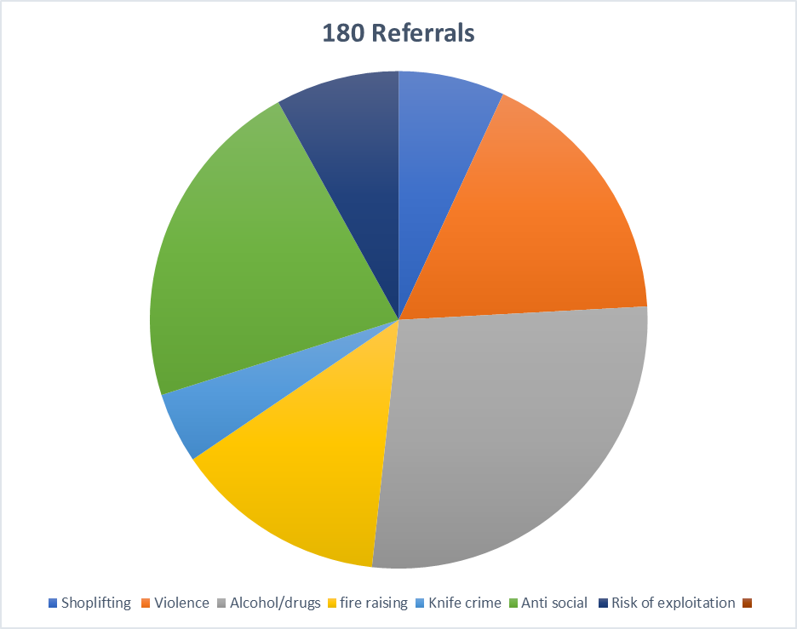

Programme outline
Week 1: Introductions/target setting
Week 2: Exploring attitudes to crime and moral responsibility
Week 3: Victim empathy (One Killer punch documentry)
Week 4: Causes and consequences of crime
Week 5: Understanding emotions (MyPAS)
Week 6: Self esteem and wellbeing (MyPas)
Weel 7: Sexual violence prevention (Rape Crisis Scotland)
Week 8: Alcohol and drug awareness (AA, NA and CA volunteers)
Week 9: Personal safety (Fire Scotland and Police scotland)
Week 10: Sexual violence peventions (Rape Crisis Scotland)
Week 11: Sexual Violence prevention (Rape crisis scotland)
Week 12: Positive changes and our futures

Evaluation methods and results
Individual target setting and target review monitoring methods are used with the young people engaging in 180 group work and 1:1 supports. Targets such as “I want to stop offending”, “I want to improve my school attendance” or “I want to become more confident” are noted and then regularly reviewed with the young person.

- Changes such as ‘increased social connection’ or ‘improvements in behaviour within the local community’ can be observed through feedback from community stakeholders as well as from the young people themselves.
- Local community police, store security personnel and business owners assist with feedback and statistics regarding incidents of shoplifting, racial abuse or threats of violence towards shop staff and members of the community.
- Referrer feedback forms are used to help monitor opinions and observations made by other professionals involved in the young person’s life and regular partnership meetings are scheduled.
- The Y2K Youth Work Coordinator attends fortnightly multi-agency Wellbeing meetings at Newbattle High School which provide important information and feedback on individual young people who are often engaged with the 180 service.
- Regular contact with the young people who attend InvolveU evening sessions and group work programmes allows staff to keep detailed and up to date records through daily evaluation processes.

The 180 Project Lead is responsible for collating 180 data from across the various services, programmes and activities to produce a comprehensive picture of the achievements of the project for the individual participants. The level of need is high and as a result of the success of the 180 pilot and InvolveU/180 service Y2K has secured funding from the Gannochy Trust and the Corra Foundation that will enable further development of the service by continuing the Project Lead post and adding a new part-time 180 project worker.
Learning, process and progress
Y2K does not hold to a ‘one-size-fits-all’ approach and through the process of the project has learned that there is no more powerful way to spread a message than word of mouth. Working with young people to encourage coaching and mentoring approaches, leadership opportunities and experience of positive attainment broadens the peer to peer reach.

By offering a range of interlinked services that have the health and wellbeing of young people at their core individuals are able to access the support they need at their own pace and when they are ready to engage. Having the 180 service means that if a young person is not able to access an InvolveU drop-in because of the ‘zero tolerance’ policy on drink and drugs or because they have been given a ‘ban’ for challenging behaviour within the drop-in, this does not preclude them from accessing other daytime Y2K services or activities. They are not ‘excluded’ from the organization, but they realise that there is a consequence for their behaviour/choice. In this way the young person does not completely miss out on the opportunity to engage with support to change their behaviour.
Being able to signpost young people on to other services whether provided by Y2K or an external agency can help them sustain momentum for change.

Financially times are challenging, and Y2K works creatively and strategically across themed services to provide early support and prevention that will impact positively on young people’s lives and futures. Reaching a high volume of vulnerable young people through informal open-door drop-ins offers the opportunity to develop targeted programmes which effectively engage young people who are already involved in low level offending within the community and for whom the causes and consequences of their behaviours are blurred.

180 in 2019
As of June 2019 the 180 service has completed seven full programmes (two girls’ groups, four mixed sex groups and one boys’ group), three of the programmes have taken place within Newbattle High School and the other four at Y2K.

Case Studies
Sarah
“Sarah” is 14, she was referred to 180 because social workers were becoming increasingly concerned with her offending behaviours. At such a young age she had already had several police reports and charges for her negative and anti-social behaviours. School exclusions were a regular occurrence and relationships with family were strained.
Sarah began attending the group work programme in November 2018, alongside other young people in a similar situation. Over a 12-week period Sarah took part in a range of group work sessions aimed at encouraging the young people to consider the choices they were making and how they might take positive steps to improve their lives. Sessions included the causes of crime, victim empathy, alcohol awareness and sexual health. As a result of her involvement with 180, Sarah began to move away from offending. Social workers shared that the number of police reports submitted for her had dramatically decreased and that her behaviour in school had massively improved. She was spending less time around negative influences and had formed more positive relationships with peers. Prior to her engagement with 180, we had been advised that there was a strong chance Sarah would be ‘accommodated’ due to the severity of her offending. However, following Sarah’s engagement with 180 social services decided that it was in her best interests to avoid this due to the progress made and this recommendation was put to the Children’s Panel where they agreed. The 180 Project Lead was invited to the hearing to share positive feedback and information on the supports that will be provided on Sarah’s completion of the 12-week programme. Sarah has told us that being part of the weekly sessions has really opened her eyes to where she was heading and made her realise that she wants to make positive changes to her life.
“I like coming to the 180 group. We actually get listened to and not judged or moaned at. The workers believe that we can change and give us a wee help when we need it. I am not drinking as much now either and don’t hang about with the folk who I was getting in trouble with before. I know I want to change and I definitely will.”
Josh
“Josh” is 15. Over a 2-year period he found himself getting into an increasing amount of trouble within the community. He had been charged for several offences and was well known in the community for being a troublemaker. Josh was engaging with risk taking behaviours, including experimenting with drugs and alcohol, which had resulted in him requiring emergency medical assistance on several occasions. He had disengaged with education and as a result of his significant police charges and dangerous behaviours, Josh was placed on a supervision order requiring him to wear a TAG and he was ‘accommodated’. Social workers involved were becoming increasingly concerned about Josh and where he was likely to end up if he did not change his ways. Social services decided that Josh would be an ideal candidate for Y2K’s 180 service. This service would offer the support, advice and interventions that Josh needed to enable him to make a positive change to his life and future. Josh began engaging with 1:1 and group work supports, exploring the causes and consequences of his behaviour and encouraging him to consider how he might have a more positive future. Josh has now not been in any trouble for the last 6 weeks; he has received no recent police charges and is behaving well within the residential unit. Josh has expressed that he wants to change and is engaging well with the supports on offer through the 180 service. He has not been using alcohol now for a 6-week period and has expressed his interest in taking part in Y2K’s Nae Butts project as a way of supporting him to stop smoking tobacco. Josh is currently working towards an accredited youth achievement award through his participation with 180. He has begun to show real maturity and develop empathy skills. He has expressed that being part of 180 has allowed him to reflect upon his life and what he wants to work towards. His school attendance has significantly increased and we have received positive feedback from his social worker, evidencing the positive impact that the 180 service is having on him. Josh will continue to take part in weekly group work sessions and 1:1 supports over the coming months, exploring a wide range of areas including victim empathy, sexual health and employability skills.

“Being part of the 180 group has helped open my eyes up to where my life is heading. I know I want to make changes and now I feel I am taking the right steps.”
James
At 14 James had a reputation for challenging & offending behaviour. He was well known to police and had been arrested for a range of crimes including violent & anti-social behaviours. He was not engaging with school - refusing to attend. He began to show an interest in coming to InvolveU drop-ins, arriving with friends, playing pool and Xbox & getting to know the team. Over time, James was supported by staff to understand the expectations of behaviour when in Y2K as well as what he could expect in return - respect, opportunities, information & advice. He became a regular attender, enjoying positive activities when he had usually been hanging out on the streets. As relationships & trust with staff developed, he began to open up & reflect on his behaviours. Workers encouraged & supported James to join a weekly 180 group programme run by Y2K within his school. Youth work staff attended a meeting with James & his guidance teacher to discuss his involvement in the programme and his timetable was adapted to ensure he could take part. James attended every session over a 12week period, during which he took part in workshops around a range of issues including victim empathy, personal safety, anger management and teamwork activities. It was hugely rewarding for all to see positive changes in James’ behaviour and attitude towards himself, school and his future. His school attendance began to improve, he was less involved in criminality and he reported feeling better able to make plans for his future. He continued to attend Y2K drop-ins where the support continued & positive peer relationships strengthened. Over the school holiday, James was involved in Y2K summer programme taking part in positive diversionary activities & trips. He has completed a Dynamic Youth award and made significant progress in turning his life around. There has been extremely positive feedback from school guidance teachers about his behaviour & general attitude and the police have shared that he has not been in any trouble for more than 6months. He is currently volunteering within the community to improve local green spaces which he really enjoys (he has achieved a Saltire Award). James recently put himself forward for Youth Rep at Y2K and was voted in by his peers. He has embraced a leadership role within the project and acting as a peer mentor across several activities & programmes.

“Being part of the groups at Y2K has really helped me. The staff actually listen and you can tell they proper care. If something goes wrong or I make a mistake they don’t judge they just try and help me get back on track.”

Photos

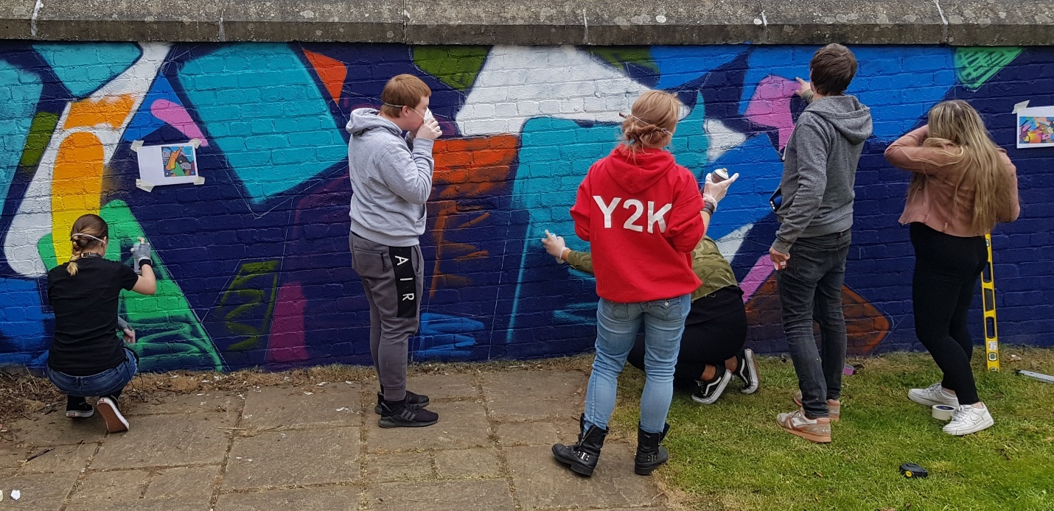
Working on garden wall mural
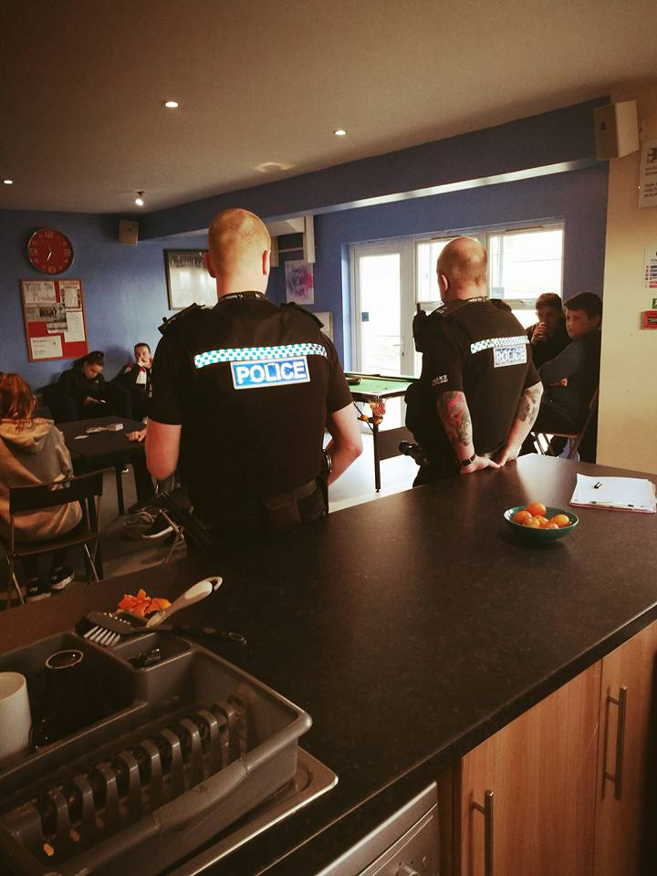
Local community police officers delivered a session around personal safety to young people.
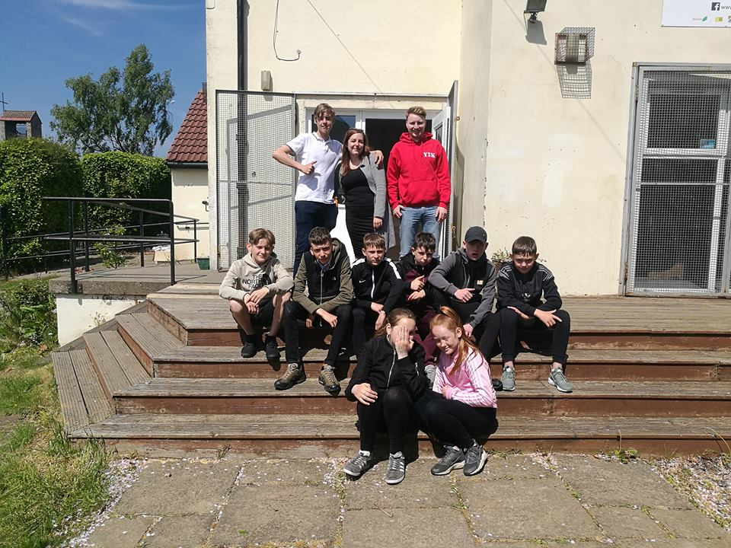
Group photo of our 180 service users, enjoying the sunshine before a trip to Ryze Trampoline centre.
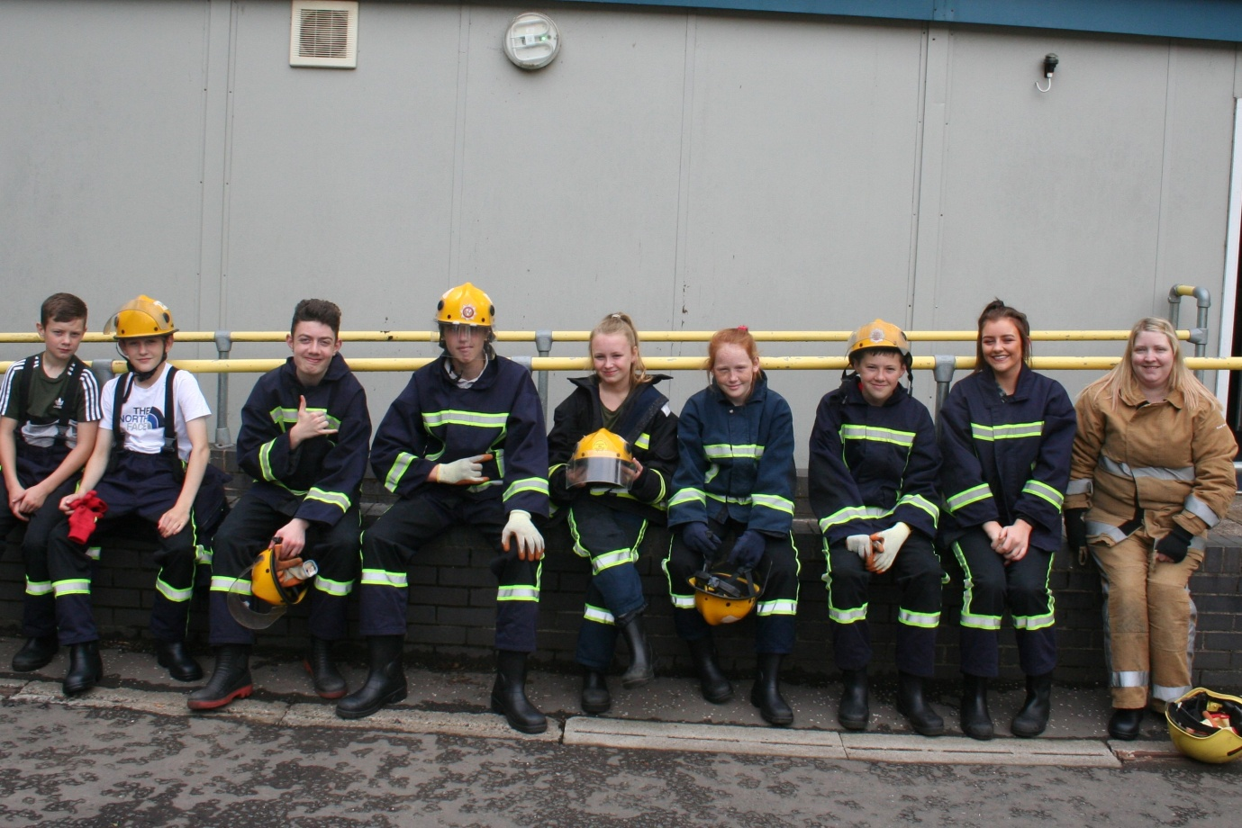
Fire safety course raising awareness of wilful fire raising and anti-social behaviours
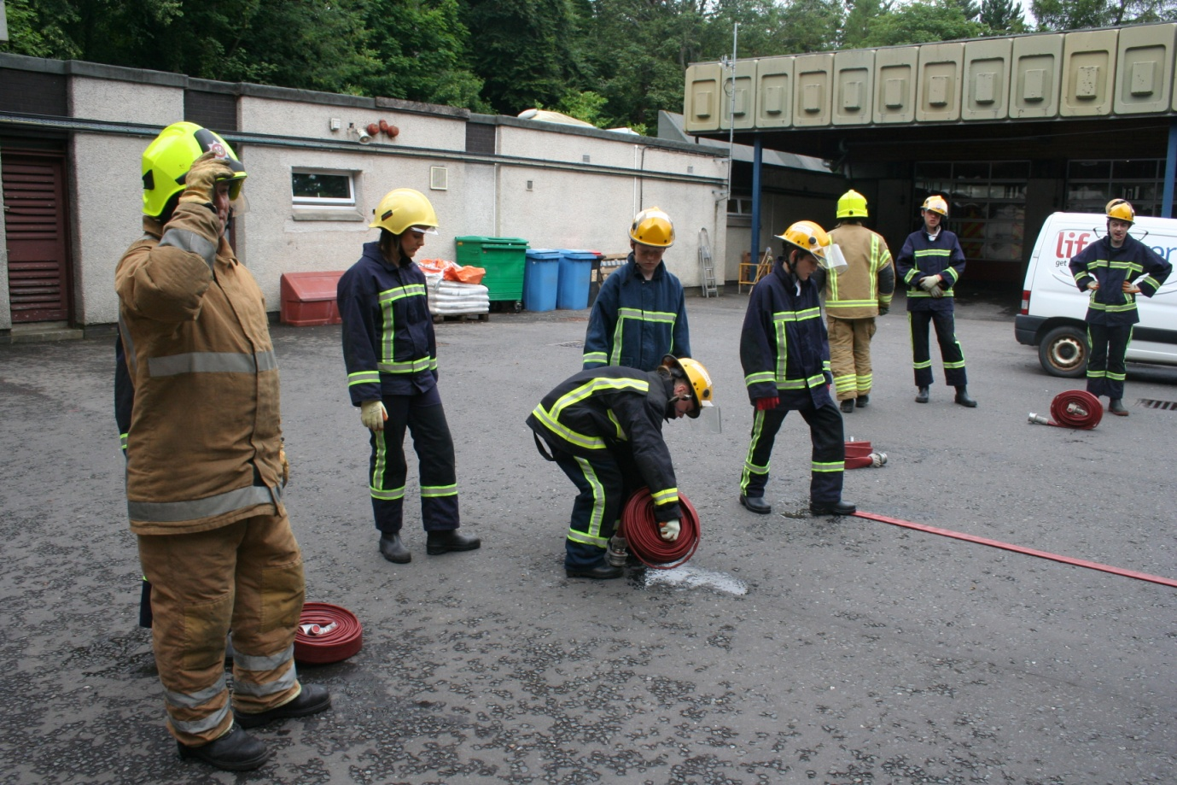
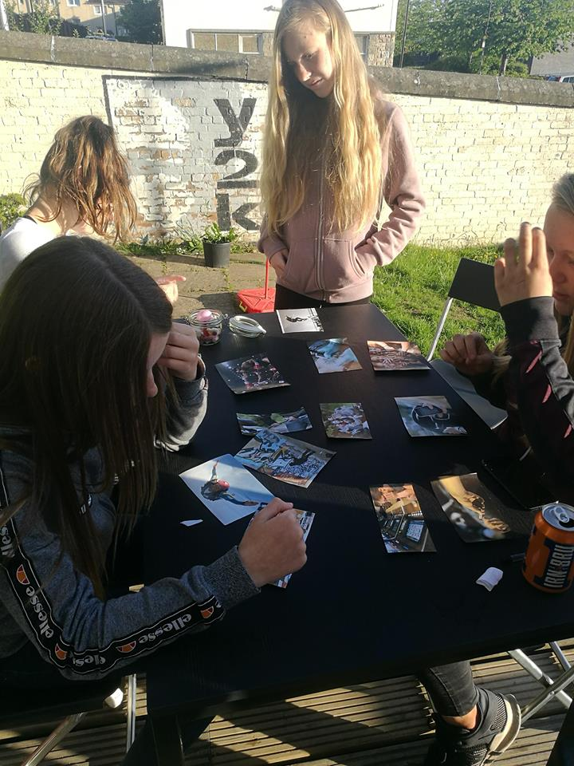
The 180 service delivered a range of workshops. The risk ladder game encouraged young people to reflect upon the risks they were taking and the consequences of these risks.
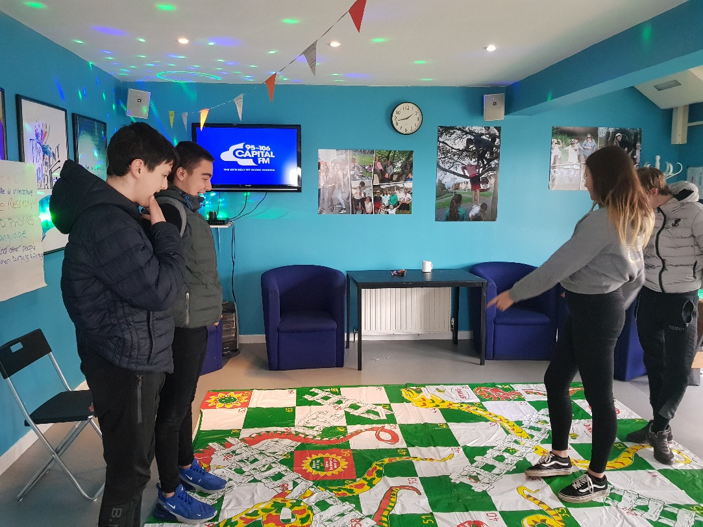
Snakes and ladders causes and consequences
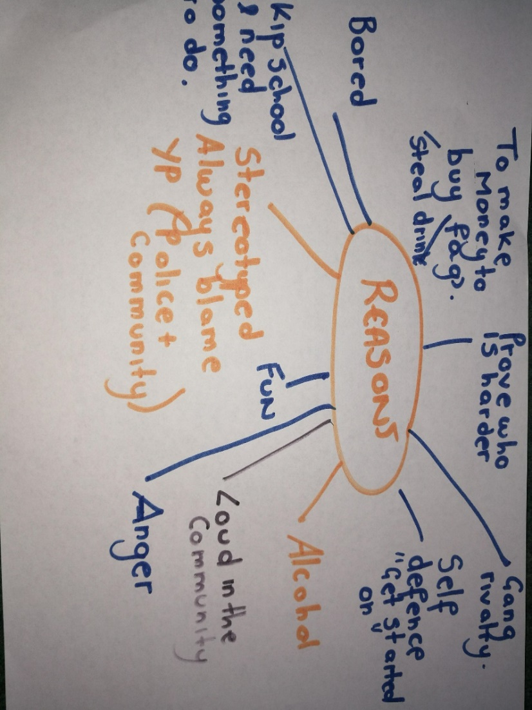
Young people discussed and recorded the reasons why young people get involved with anti-social and offending behaviours.
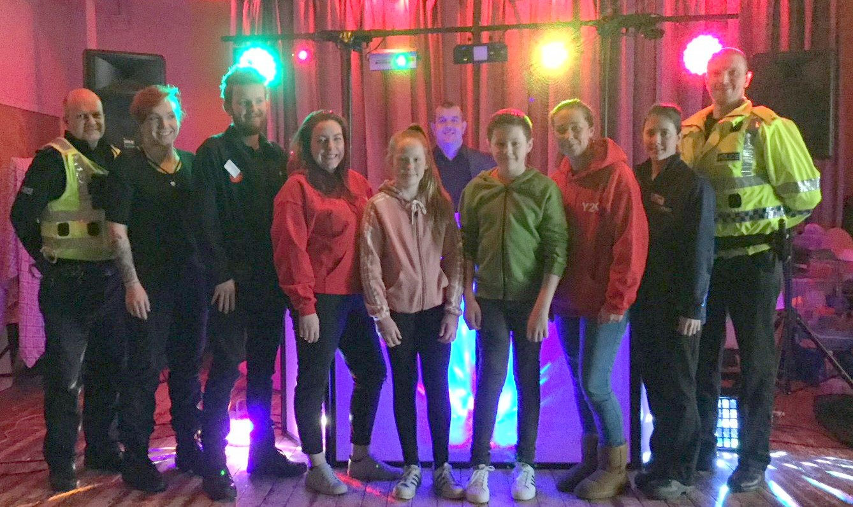
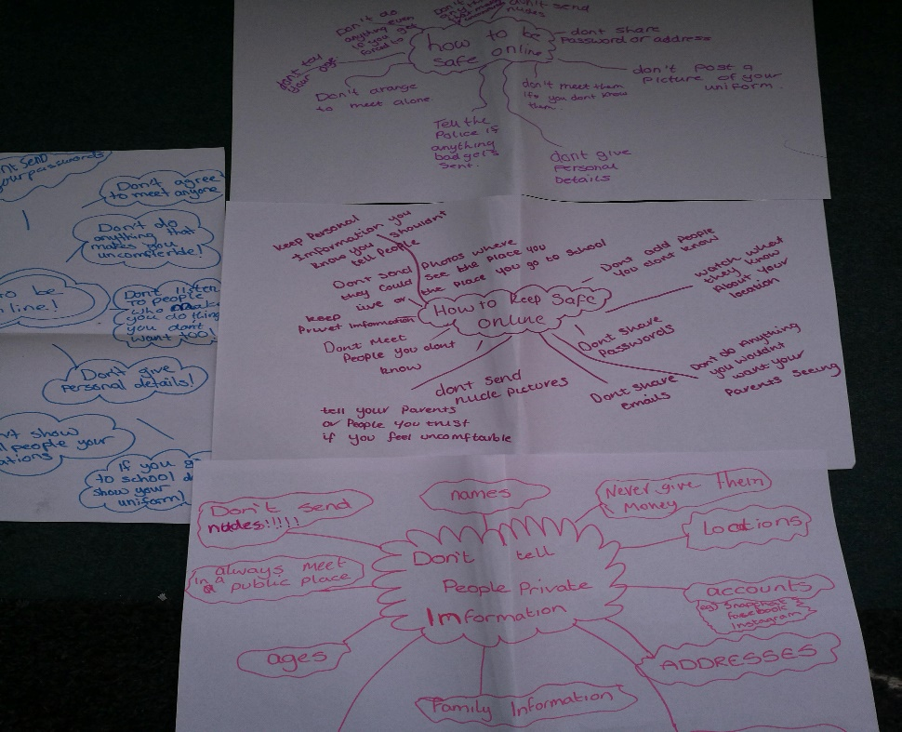
Early supports were delivered that allowed young people to learn more about a wide range of issues including online safety.
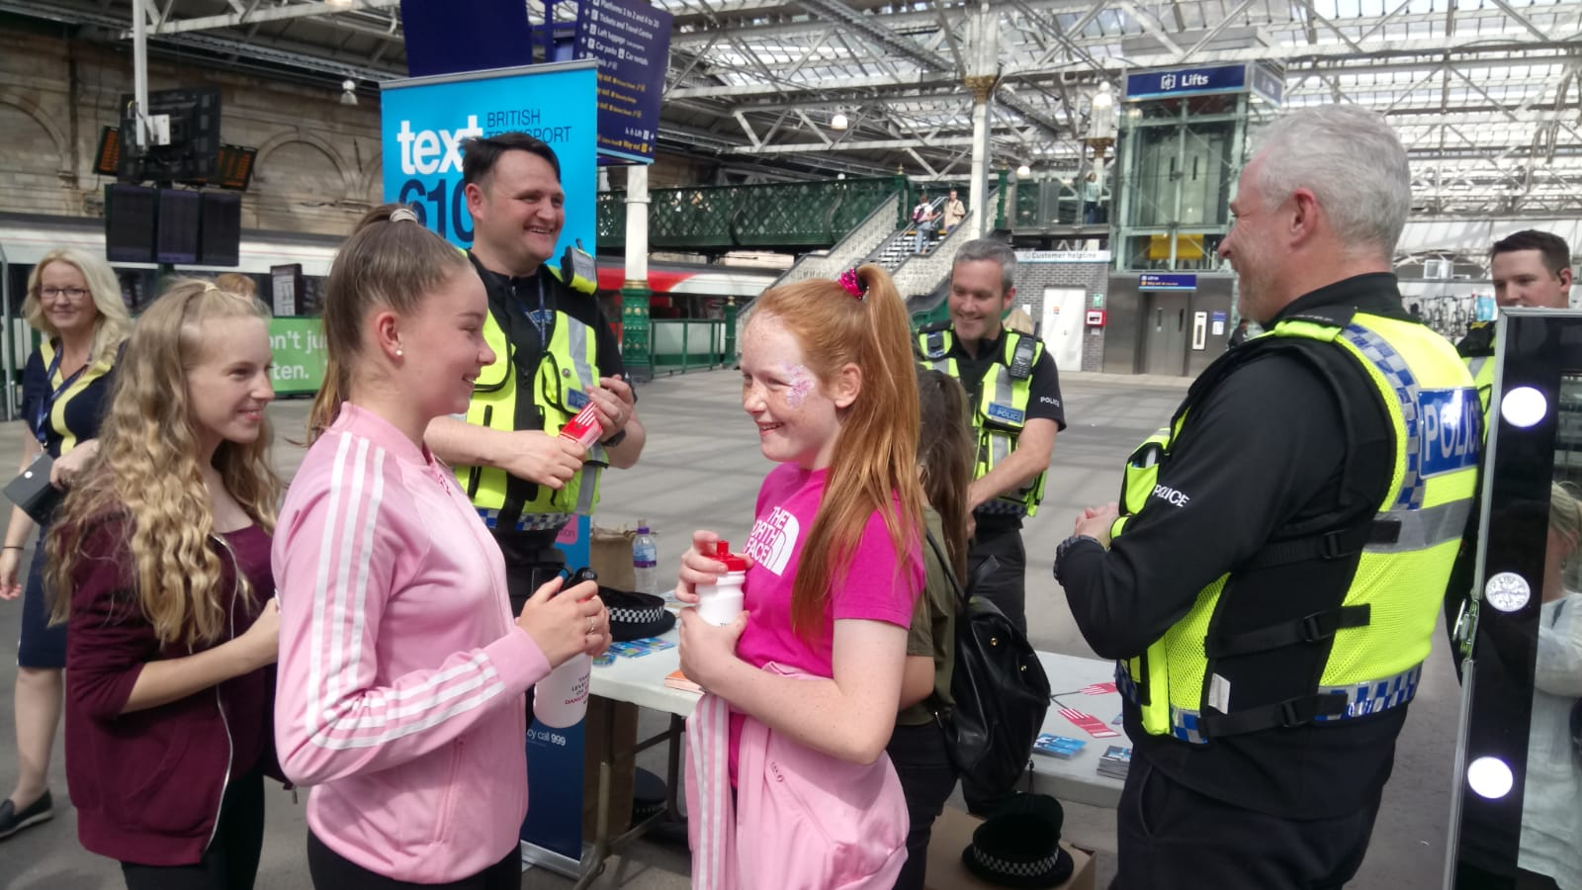
The 180 pilot encouraged young people to build positive relationships with the police.

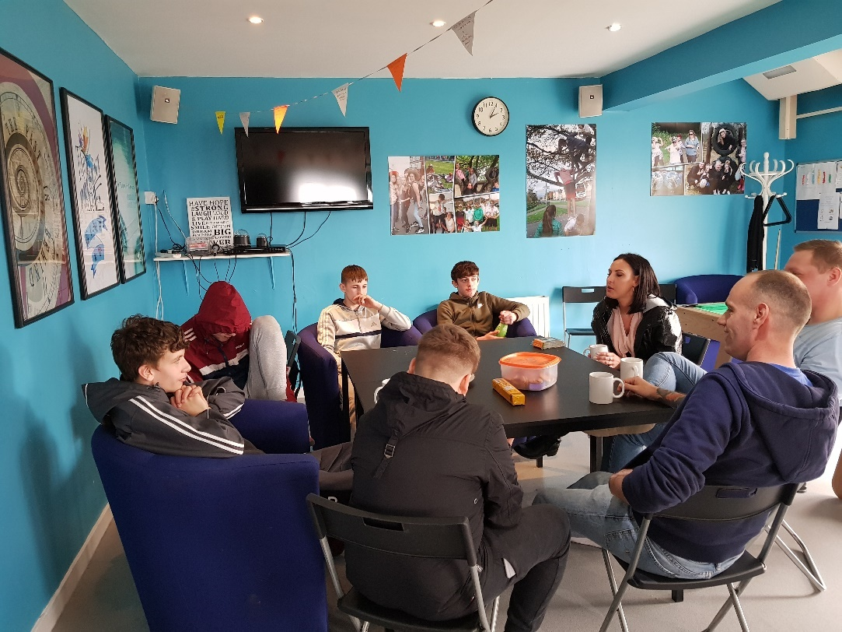
Alcohol and drugs chat
Young people were able to participate in positive diversionary risk taking activities and trips. 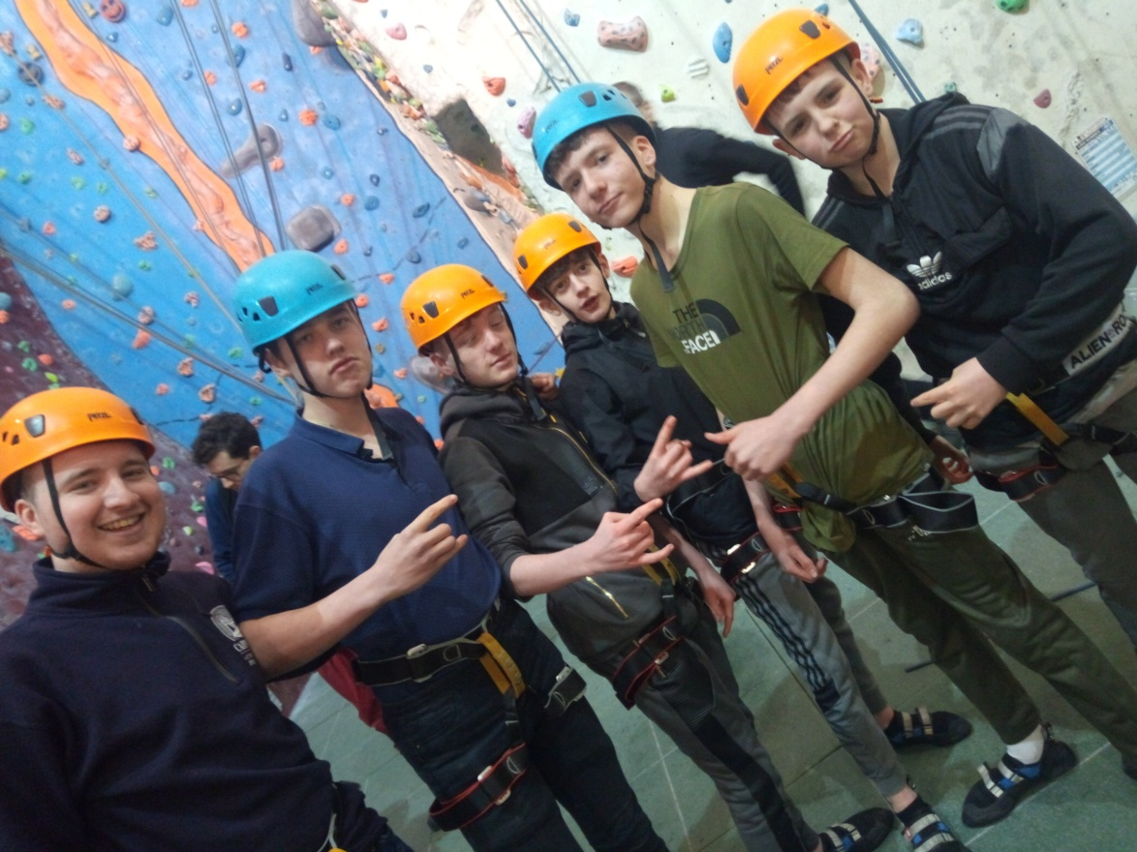

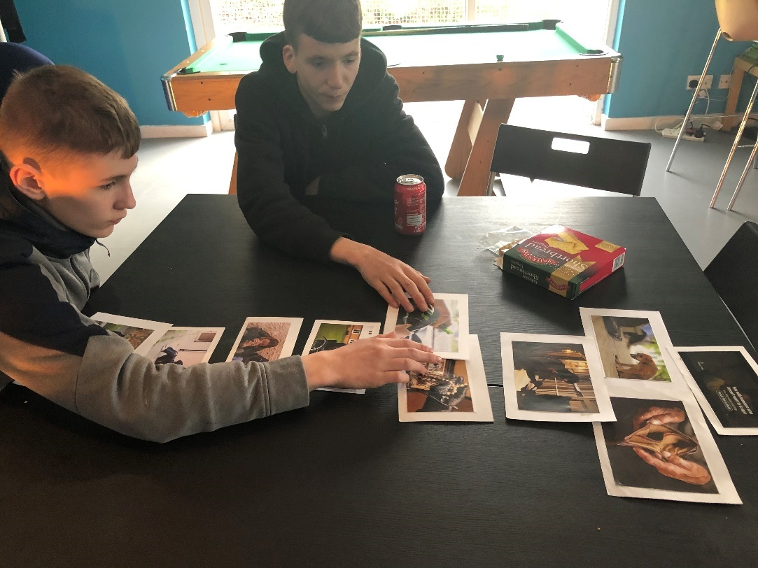
Attitudes to crime
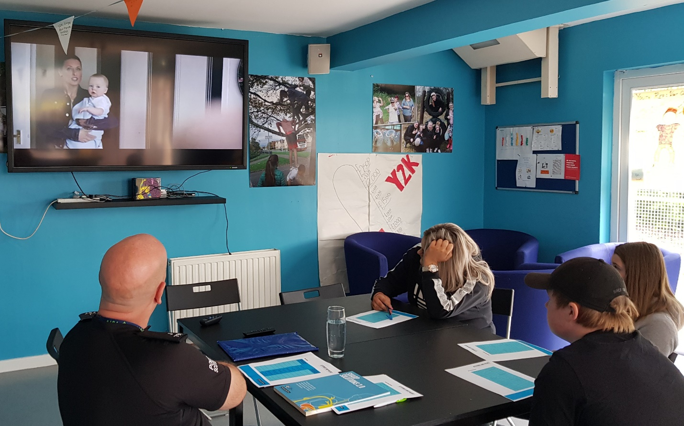
No knives better lives

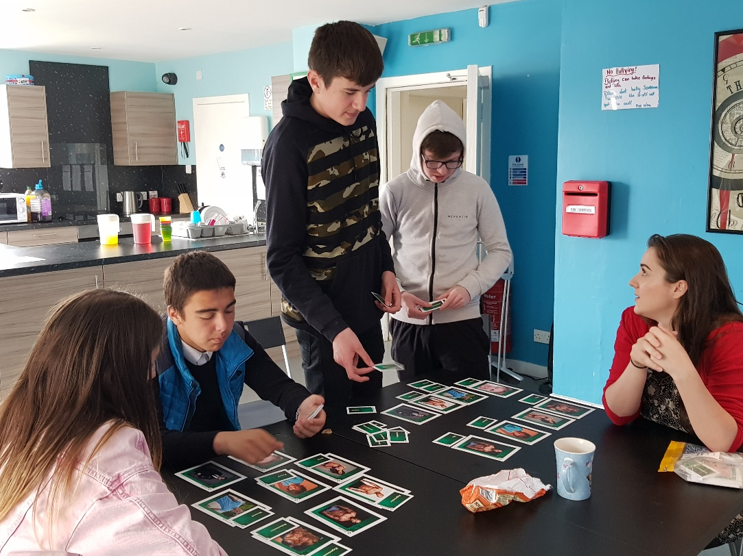
Sexualisation workshop
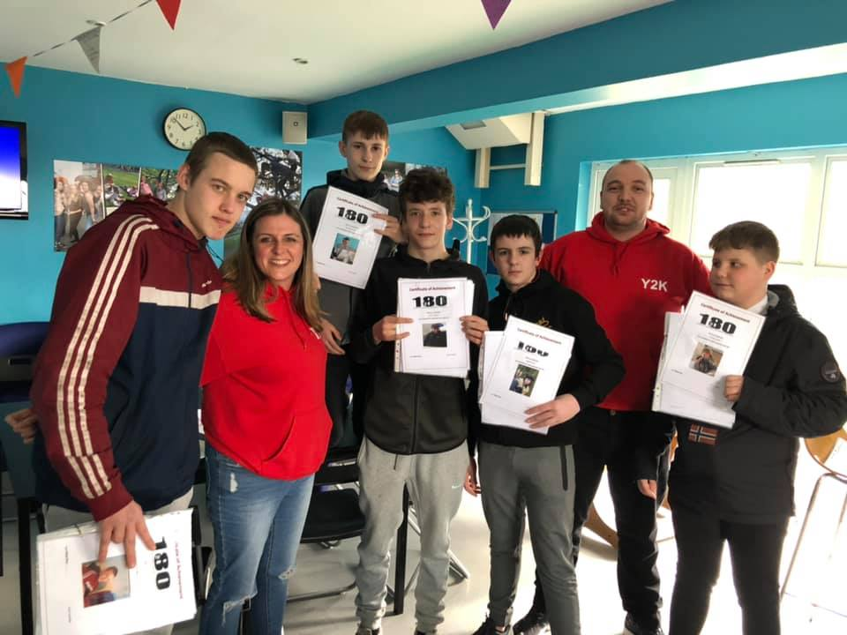
Completion certificates

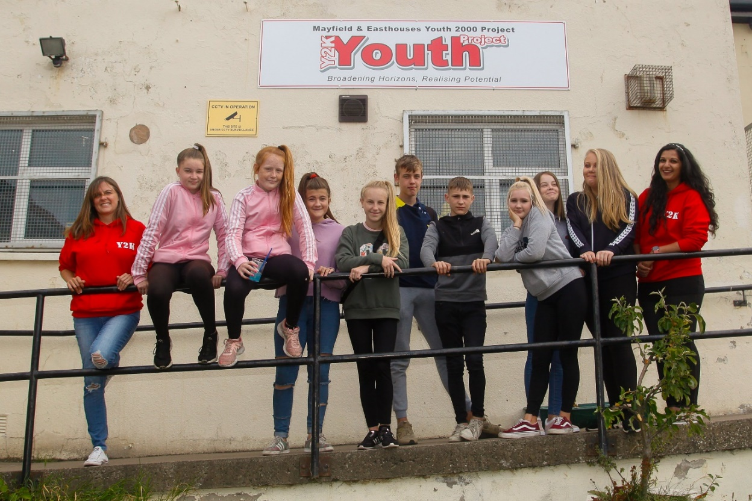
What the young people said
“The youth workers listen to us and actually care about what we say and do”
“I have had so much fun and got to try things I would never have been able to do without Y2K giving us this opportunity”
“Being part of the 180 project has made me think a bit more about where my future is heading and I think I need to make some changes now”
“I have learned that the police are actually not that bad…In fact their pretty sound”
“The summer programme kept me busy and entertained, keeping me out of bother. Normally I would just be bored and so hang about the streets, setting fires and stuff. This summer I haven’t been lifted once and I have done stuff like outdoor combat and canoeing. It was quality”
“I took part in really good workshops about things like alcohol awareness. The session about victim empathy really made me think about how my behaviour is affecting others and I don’t want to do that to people I love”
“I am going back to school and I have realised I need to screw the head on and work hard. I’m not wanting to be getting chased from the police any more. I need to think about the future now

Feedback from Community Stakeholders
I write in support of Y2K and the fantastic work you are undertaking within the community with our young people. The partnership that has been established with my community and youth campus officers is one of the strongest we have in Midlothian. I provide you with their support as front line staff dealing with the challenges you address in partnership. It goes without say that we truly value the excellent service you provide, and the outcomes achieved in partnership are simply first class

Kenny Simpson, Chief Inspector, Area Commander – Midlothian, Police Scotland
We regularly visit the Y2K on Friday evenings and it is well attended with at least 50 children using the facilities within. It is clear when within that the staff are passionate about what they're doing. Everyone gets involved and in our opinion this keeps the youths busy and gives them something to do when you often hear a lot of the children who are involved in criminality saying "there's nothing for us to do". James and I have built up a great relationship with the local schools in the community and continue to do so whether we attend and carry out school talks or go see them at the Y2K.

PC Brian McGuff and PC James Pendreich, Gorebridge Community Officers

I have worked with Y2K in my role many times. They attend all the Newbattle Wellbeing meetings and contribute with their local knowledge of kids and families. They also carry out group work both at Y2K and in Newbattle HS with high tariff groups of youths. This involves smaller workshops which involves discussing offending, ASB, coping mechanisms and many other tools to assist these kids. They also carry out one to one work with kids who don’t work well in group formats. The work they carry out is invaluable to Police in Midlothian due to their local knowledge of the area and of the families they support. For some high tariff young males, this is one of the few places that they can attend and feel part of, without intimidation or peer pressure. Without this, some of these kids could revert back to ASB and youth offending, it would be a great blow to the other multi agencies within Midlothian.

PC Iain Anderson, Youth Campus Officer (Newbattle/Lasswade High School and Midlothian PSYV Co-ordinator)

We deal regularly with youth related matters, be it challenging behaviour, ASB, offending, mental health issues etc. As such, over the last couple of years or so we have worked collaboratively with staff at Y2K and established a very good relationship. Y2K is the only group that works with young people, providing support for them and their families, offering advice and life skills and all manner of work to steer ‘high tariff’ youths to better decision making and away from dangerous/risk taking behaviours and offending for the whole of the Midlothian area. With the relationship established they have supported police with sharing information on and signposting certain youths with a view to early intervention and allowing Scott and I opportunity to do preventative work, thus reducing calls to police relating to youth ASB and offending. This can be evidenced by figures for calls to police, crime reports relating to youth ASB/offending etc for the Mayfield & Easthouses area of Midlothian over the last year or so.
In the Summer months they provided courses for youths, one of them in conjunction with the fire service, for which Scott and I have played a part in providing inputs to high tariff youths that previously we had only dealt with in challenging situations. This has enabled opportunity to ‘build bridges’ with those who have only ever had a negative view of police, as well as for us of them, we have therefore obtained better understandings with certain youths which could bode well going forward should we have to deal with them again in different situations.
The trained staff are now also giving support to Newbattle High School, again in respect with challenging and high tariff youths that otherwise would likely be left to their own devices, likely be excluded and therefore cause problems in the local community.

PC Trevor Newton-Jones and PC Scott Lambert, Mayfield/Easthouses Community Officers

Since starting work in Newbattle High it is more than apparent to me that Y2K are invaluable to both the kids and the teaching staff. It’s clear the kids trust them and feel safe attending the Y2K premises as for many this is their 'place of safety'. The staff are often the first to report issues and lately have highlighted some very important concerns that the kids have felt confident disclosing to them, and this has enabled the school/appropriate agencies to step in and assist. Further to this, the organisation clearly helps in cutting the anti-social behaviour caused in the Mayfield area in particular as the kids have stated that they don't feel the need to hang around the streets as they have some where to go in the evenings, and speak very highly of both the staff and the organisation in general and this is not something you hear often from the kids! Y2K also do a lot of one to one work in the school with some of the more 'difficult' kids and again this has shown to be extremely beneficial and assists in alleviating some of the time the teaching staff have to find to do this.

PC Kerry Wilson, Positive Learning and Behaviour Officer, Newbattle Community High School
We have benefitted greatly from increased support from our partners at Y2K. The commitment that is shown to supporting the pupils in our community is excellent. In addition to the facilities and activities they offer to pupils in the evenings, they are a key partner agency for us in the work that we do in and beyond school. Currently we have 3 groups running through Y2K within the school; an s3/4 boys’ group, an S3 girls’ group and an S1 group. These groups are always well-attended and highly valued by the young people, focussing on positive relationships, risk-taking behaviour and self-esteem and confidence. In addition, we have a large number at any one time receiving one-to-one support for a range of issues, often an attempt at early intervention work for young pupil experiencing difficulties. The Y2K staff are flexible, creative and sensitive to the needs of the pupils at Newbattle. They work with pupils who are in very challenging situations, such as Care Experienced, and do preventative work for those who present challenge, e.g those at-risk of exclusion.

Mr Gib McMillan, Headteacher, Newbattle Community High School

See Scottish Government, SIMD: https://www2.gov.scot/Topics/Statistics/SIMD
For example, see Midlothian Council’s 2016 Neighbourhood Profile: file:///C:/Users/Surface/Downloads/Mayfield_Easthouses_2016.pdf

